Test : Đề thi Toeic : tháng 4 năm 2011
(thời gian làm bài 120 phút)
LISTENING COMPREHENSION
────────────────────────────────────────────────────

Part I: Picture [00:03]
Directions: In your test book, you will see a picture. On the compact disc, you will hear four statements. Choose the statement that most closely matches the picture and fill in the corresponding oval on your answer sheet.
1. Look at the picture marked number 1 in your test book.
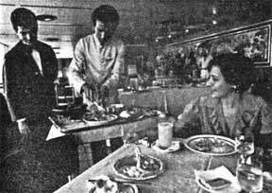
2. Look at the picture marked number 2 in your test book. [00:42]
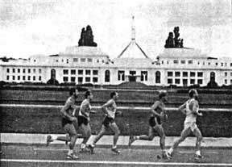
. √
3. Look at the picture marked number 3 in your test book. [01:05]
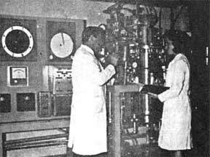
4. Look at the picture marked number 4 in your test book. [01:30]
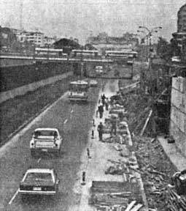
5. Look at the picture marked number 5 in your test book. [01:52]
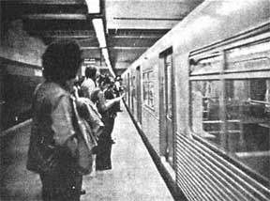
6. Look at the picture marked number 6 in your test book. [02:14]
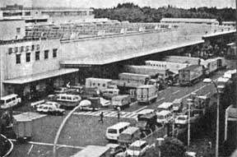
7. Look at the picture marked number 7 in your test book. [02:37]
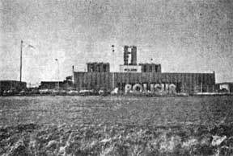
8. Look at the picture marked number 8 in your test book. [03:01]
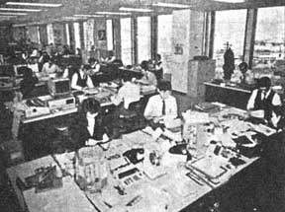
.
9. Look at the picture marked number 9 in your test book. [03:23]
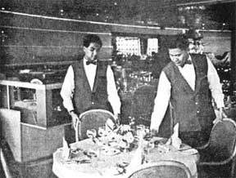
10. Look at the picture marked number 10 in your test book. [03:44]
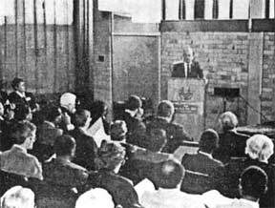
11. Look at the picture marked number 11 in your test book. [04:06]
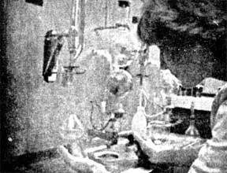
12. Look at the picture marked number 12 in your test book. [04:30]
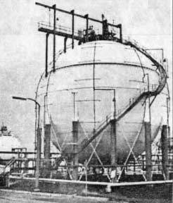
13. Look at the picture marked number 13 in your test book. [04:53]
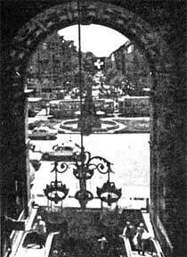
14. Look at the picture marked number 14 in your test book. [05:16]
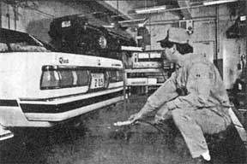
15. Look at the picture marked number 15 in your test book. [05:40]
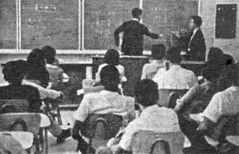
.
16. Look at the picture marked number 16 in your test book. [06:04]
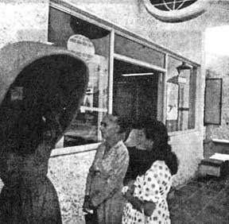
.
17. Look at the picture marked number 17 in your test book. [06:26]
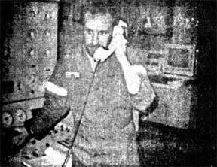
18. Look at the picture marked number 18 in your test book. [06:49]
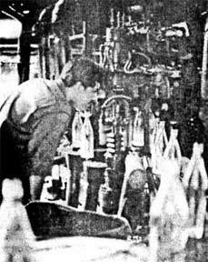
.
19. Look at the picture marked number 19 in your test book. [07:14]
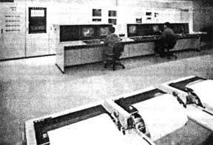
20. Look at the picture marked number 20 in your test book. [07:39]
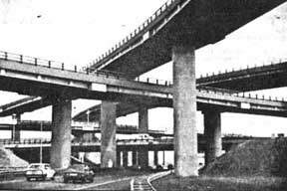
Part II: Question-Response [08:01]
Directions: On the compact disc, you will hear a question and three possible answers. Choose the answer that most closely answers the question ( 21-50) and fill in the corresponding oval on your answer sheet.

Part III: Short Conversations [16:29]
Directions: On the compact disc, you will hear a short converstation. In your test book, you will see a question and four possible answers. Choose the best answer to the question and fill in the corresponding oval on your answer sheet.
51.Why can't they go after work?
(A) It's dark. √
(B) It's in the park.
(C) It's going to rain.
(D) They don't have warm clothes.
52. What does the woman want to do?
(A) Get a magazine.
(B) Leave the bank.
(C) Buy some traveler's checks. √
(D) Look for a desk.
53. What should people do if they get lost?
(A) Stay with the tour.
(B) Find the bus. √
(C) Go to the market.
(D) Take a bus on Main Street. (Wait a bus on Main Street thì được)
54. What should the woman do?
(A) Cash a check.
(B) Get a roll of quarters. √
(C) Change buses.
(D) Check her coins.
55. What is the man going to do?
(A) Figure sales.
(B) Illustrate programs.
(C) Sell computers.
(D) Make graphs and charts. √
56. Where does this conversation take place?
(A) In a movie theater.
(B) On a plane. √
(C) On a bus.
(D) In an auditorium.
57.When should the housekeeper clean the room?
(A) Before 11:00. √
(B) After 11:00.
(C) At the scheduled time.
(D) At 2:35.
58.What is the appoinment for?
(A) A medical checkup.
(B) A sales meeting.
(C) A possible presentation.
(D) A job interview. √
59. What might solve the problem?
(A) Mopping it up.
(B) Fixing the leak. √
(C) Building a stand.
(D) Keeping it wetter.
60..When will the television set be already?
(A) Today.
(B) On week.
(C) Two weeks.
(D) Three weeks. √
61.What is the man going to do?
(A) Manage the director.
(B) Wear glasses.
(C) Meet the director. √
(D) Introduce the director.
62. What should the woman expect tomorrow?
(A) A newspaper. √
(B) Some stationery.
(C) More room.
(D) A directory.
63. Why do they need Mr. Chung?
(A) To address some letters.
(B) To speak at a meeting. √
(C) To show the film.
(D) To announce the date.
64. How will the man pay for the sweater?
(A) Charge it.
(B) With a check. √
(C) With a credit card.
(D) Pay cash.
65. Where does the man want to go?
(A) The park.
(B) The capitol building.
(C) The train station
(D) The history museum. √
66. What does the man do during his lunch hour?
(A) Takes a walk.
(B) Exercises.
(C) Eats lunch. √
(D) Tries to work.
67. Why was the letter returned?
(A) It didn't contain a check.
(B) The street didn't exist. √
(C) The company sent it back.
(D) The man didn't mail it.
68.What was wrong with the lobby before?
(A) It was too light.
(B) It was out of style.
(C) It was too white.
(D) It was too dark. √
69. What are the man and woman doing?
(A) Working hard.
(B) Scheduling a meeting.
(C) Introducing themselves. √
(D) Leaving a party.
70. Where does the man want the desk?
(A) By the door.
(B) Under the lamp.
(C) In the entrance.
(D) By the window. √
71. What does the project need?
(A) A different schedule.
(B) Fewer people.
(C) A special assignment.
(D) Some temporary workers. √
72. What is the man's problem?
(A) He's meeting too many people. √
(B) There's no place to have the meeting.
(C) There's no schedule for Tuesday.
(D) No one is attending the conference.
73. Why can't the woman take her suitcase with her?
(A) They have to examine it.
(B) It's too heavy.
(C) It's too large. √
(D) She has to many carryons.
74. Why didn't the man get an answer?
(A) They're taking a break. √
(B) They're out on a lake.
(C) They've broken a plane.
(D) They're out in the rain.
75. Where did this conversation probably take place?
(A) At a convention.
(B) During a performance.
(C) At a meeting.
(D) On a tour. √
76. Why don't they call a repair person?
(A) The printer is working.
(B) The printer is too old.
(C) The printer is guaranteed. √
(D) The printer is still good.
77. What is the woman's profession?
(A) Ticket agent.
(B) Flight attendant. √
(C) Baggage handler.
(D) Caterer.
78. Why does the man want a gas station?
(A) He's out of gas.
(B) He's tired.
(C) He's on a long road.
(D) He has a flat. √
79. How does the man feel?
(A) Rested.
(B) Sleepy. √
(C) Motion sick.
(D) Unstable.
80.What does the woman need to do first?
(A) Read the report. √
(B) Comment on the report.
(C) Recommend the report.
(D) Think about the report.

Part IV: Short Talks [24:41]
Directions: On the compact disc, you will hear a short talk. In your test book, you will see several questions on the talk and four possible answers. Choose the best answer to the question and fill in the corresponding oval on your answer sheet.
81. What is wrong with the number that was dialed?
(A) It is the wrong number.
(B) It is not working. √
(C) It has an answering machine.
(D) It has a busy signal.
82. Who will help you if you stay on the line?
(A) A repair person.
(B) An operator.
(C) A customer service representative. √
(D) A telephone executive.
83. What is wrong with the water supply?
(A) There is no more water.
(B) The water tastes bad.
(C) The water is contaminated. √
(D) The water is rusted.
84. How can residents make the water safe?
(A) Boil it. √
(B) Freeze it.
(C) Put tablets in it.
(D) Let sediment settle before drinking.
85. What kind of training does this school provide?
(A) Computer training. √
(B) Business management.
(C) Personnel training.
(D) Teacher training.
86. How long will the training take?
(A) Three months.
(B) Six months. √
(C) Nine months.
(D) One year.
87. Where is this train going?
(A) New York and Baltimore.
(B) New York and Wilmington.
(C) New York and Philadelphia.
(D) New York and Boston. √
88. Where should New York passengers board the train?
(A) At the front. √
(B) At the back.
(C) In the middle.
(D) Anywhere.
89. When should you call back?
(A) In the evenings.
(B) On Saturdays.
(C) During business hours. √
(D) Early in the mornings.
90. If you can't call back, how can you contact the company?
(A) Vie e-mail.
(B) Write them a letter. √
(C) Sent them a fax.
(D) Go to their office.
91. How should you apply for these jobs?
(A) Send a résumé.
(B) Go to the hotel. √
(C) Write a letter.
(D) Make a phone call.
92. What do the jobs offer, besides a good wage?
(A) Benefits.
(B) Free food.
(C) Good hours.
(D) Possible promotions. √
93. Where can this recording be heard?
(A) At a movie theater.
(B) In a parking area. √
(C) At an amusement park ride.
(D) In an airport.
94. Why should you keep your ticket?
(A) To gain entrance.
(B) To see if you win.
(C) To leave. √
(D) To identify your possessions.
Now read question 95/96/97 in your test book and answer it.
95. What problem can the city expect?
(A) An epidemic.
(B) Extremely hot weather. √
(C) Flooding.
(D) Infestation of insects.
96. How high are the temperatures expected to be?
(A) In the seventies.
(B) In the eighties.
(C) In the nineties.
(D) In the hundreds. √
97. How can citizens protect themselves?
(A) Wear dark clothing.
(B) Exercise frequently.
(C) Drink lots of water. √
(D) Swim.
Questions 98 through 100 refer to the following announcement. [30:32]
98. What advice is given for busy executives?
(A) Delegate tasks to others.
(B) Keep your secretary busy.
(C) Work overtime.
(D) Establish a quiet hour. √
99. How can you keep others from disturbing you?
(A) Stay away from your office.
(B) Close your office door. √
(C) Display a DO NOT DISTURB sign.
(D) Refuse to handle emergencies.
100. What should you do during this time?
(A) Work on difficult tasks. √
(B) Return phone calls.
(C) Complete projects that are overdue.
(D) Work closely with staff.

***********************************^{[end]}*********************************
II: READING
101. Residents began to ------- the area after hearing
news the volcano would erupt.
(a) gain
(b) remake
(c) commute
(d) evacuate
102. Analysts ------- the country improve its infrastructure
to get foreign investment.
(a) suggested
(b) suggest to
(c) suggesting
(d) were suggested
103. In accordance with market trends, food and drink
companies ------- healthier images.
(a) looked
(b) sought
(c) helped
(d) believed
104. With a wide -------, Mr. Gonzales was re-elected
president of the South American country.
(a) term
(b) voter
(c) margin
(d) border
105. The airline avoided a strike by ------- with the pilots’
union.
(a) negotiate
(b) negotiates
(c) negotiating
(d) negotiation
106. The report showed the U.S. trade deficit ------- in
February.
(a) shrink
(b) shrunk
(c) shrunken
(d) shrinking
107. Union members ------- the privatization of the
country’s airports.
(a) replied
(b) annoyed
(c) protested
(d) identified
108. Scientists ------- new ways to attack the fungus
damaging the rice fields.
(a) develops
(b) to develop
(c) were developed
(d) are developing
109. The controversial film was nominated ------- eight
Academy Awards.
(a) of
(b) for
(c) with
(d) about
110. The advertising executive resigned over his
inappropriate ------- made at a conference.
(a) dress
(b) acting
(c) welcome
(d) remarks
111. About 30,000 coffeemakers were ------- after the
company received numerous reports of overheating.
a) released
(b) recalled
(c) reentered
(d) refigured
112. Pest control was called to ------- the office over the
holiday weekend.
(a) come
(b) treat
1
(c) makes
(d) attend
113. Fears of another interest ------- caused stocks to
further decline.
(a) hike
(b) hikes
(c) hiked
(d) hiking
114. Commercial logging and overgrazing made the land
less compact and ------- to landslides.
(a) ready
(b) defensive
(c) vulnerable
(d) threatening
115. In a good year, Mr. Issa could ------- eight tons of
cocoa.
(a) apply
(b) reduce
(c) succeed
(d) harvest
116. Shareholders voted to have more influence ------- the
executive board’s decisions.
(a) over
(b) from
(c) into
(d) above
117. Parliament passed a law that would ban the
production and sale of genetically ------- food.
(a) modify
(b) modified
(c) modifies
(d) modification
118. The company chairman was ------- the acquisition
would have a positive financial start.
(a) carefree
(b) confident
(c) concerned
(d) questioned
119. Although the civil war ended four years ago,
democratic ------- have yet to be held.
(a) mistakes
(b) campaign
(c) elections
(d) following
120. New packaging helped Green Plus ------- market its
already well-known soft drinks.
(a) success
(b) successes
(c) successful
(d) successfully
121. According to the satellite survey, the Amazon
rainforest is ------- twice as fast as previously estimated.
(a) applying
(b) removing
(c) depleting
(d) renovating
122. Increasing energy stocks and a rise in foreign
investments ------- to the rise in hedge funds.
(a) helped
(b) assisting
(c) recognizing
(d) contributed
123. The celebrity couple sold pictures of their baby for $5
million, which ------- to charity.
(a) donated
(b) was donated
(c) is donation
(d) had donated
124. The retiring editor named the senior reporter as his
--------.
(a) success
(b) successor
(c) successes
(d) successful
2
125. A boom in ethanol research and manufacturing -------
jobs throughout small towns across the nation.
(a) create
(b) created
(c) creating
(d) creation
126. The position requires all candidates to speak English
------- to another European language.
(a) addition
(b) in addition
(c) of addition
(d) additionally
127. Forrest, Inc. increased its second quarter profit and
forecast ------- a large tax settlement.
(a) after
(b) being
(c) within
(d) because
128. Continual ------- of trademarks and copyrights
increased trade tension in Asia.
(a) violence
(b) writings
(c) violations
(d) understanding
129. The European country unexpectedly raised interest
rates in ------- of inflation.
(a) fear
(b) fears
(c) feared
(d) fearing
130. Owners of Movie Place, a popular movie-themed
restaurant, announced a new restaurant ------- in
Sacramento this summer.
(a) opening
(b) to open
(c) would open
(d) for opening
131. The oil giant will invest nearly ￡300 million to
research renewable energy --------.
(a) choice
(b) section
(c) portions
(d) alternatives
132. Although he was widely ignored, the lawmaker -------
his colleagues to pass bills supporting energy alternatives
to fight rising oil prices and diminishing reserves.
(a) set
(b) urged
(c) tried
(d) defended
133. A large portion of the donation was spent ------- new
ways to fight malaria.
(a) on promoting
(b) in promotion
(c) of promoting
(d) for promotion
134. Future Bank will start offering special incentives to
employees who ------- hybrid cars starting September 1.
(a) purchase
(b) purchases
(c) purchased
(d) purchasing
135. The poem was as beautiful in its English ------- as it
was in its original German form.
(a) translate
(b) translated
(c) translating
(d) translation
136. After three weeks of -------, the stock market finally
closed at a half percent increase.
(a) unsteady
(b) weakening
(c) changeable
(d) instability
137. City officials hope the new policy will make offenders
------- accountable.
(a) some
3
(b) more
(c) also
(d) with
138. Although it is not ------- on the menu, Taco Town
occasionally offers homemade tamales.
(a) listed
(b) checked
(c) placing
(d) showing
139. Sarah and Jonathan will meet this Wednesday -------
their presentation.
(a) rehearse
(b) rehearsing
(c) to rehearse
(d) for rehearsing
140. Graduate students went on strike after losing their
union -------.
(a) represent
(b) represents
(c) represented
(d) representation
Questions 141-143 refer to the following letter.
141. Feel the rush of sophistication and class!
The all-new Speedlite X-Class will drive you to a world you have _____ of.

(a) met
(b) wanted
(c) created
(d) dreamed

142. With more power, handling, and style, the Speedlite X-Class is a revolution _____ auto making.
(a) on
(b) in
(c) to
(d) up
143."Motor Trend magazine called it, “Car of the Year.”
The Speedlite X-Class _____ equipped with power steering, 5-speed manual transmission, and
side curtain airbags.
(a) came
(b) come
(c) comes
(d) coming
As a bonus, it also features a satellite navigation system and a built-in DVD player. Change your
world today, visit your local Speedlite dealer.
Questions 144-146 refer to the following letter.
Hello everyone,
As suggested _____ human resources, we will be conducting our first diversity workshop next Monday.
144. (a) by
(b) into
(c) after
(d) before
145. The purpose of the workshop is to build _____ about cultural issues.
(a) awareness
(b) recognize
(c) understand
(d) relationship
146. Staff can sign up for the workshop at the Human Resources Office. Registration is _____.
(a) curious
(b) original
(c) mandatory
(d) interesting
Thank you for your cooperation and understanding.
Frank Myers
Director of Human Resources.
Questions 147-149 refer to the following letter.
Calling all Koi lovers!
The GMAC Convention Center will _____ a Koi Convention May 22-25 from 9-9. Admission is
$10.
147. (a) holding
(b) have held
(c) be holding
(d) been holding
There will be a variety of Koi from Japan on _____ with more than a dozen varieties and sizes of
Koi on sale.
148. (a) display
(b) showing
(c) present
(d) available
A special Koi breeding class will be held on Sunday at 2 p.m. Class is _____ to 15 participants.
149. (a) restrict
(b) restricts
(c) restricted
(d) restricting
To sign up for the workshops or for more information, please visit www.gmac.com/koi.
Questions 150-152 refer to the following letter.
Tour Russia’s “Window to the West”
5
Looking for an exotic vacation? Rich in both culture and history, St. Petersburg showcases the
_____ of Russia in one beautiful location.
150. (a) diverse
(b) diversity
(c) diversify
(d) diversification
_____ by Peter the Great 300 years ago, St. Petersburg is now the second largest city in Russia.
151. (a) Known
(b) Looked
(c) Founded
(d) Traveled
Stroll along the main avenue of Nevsky Prospekt, visit The Hermitage museum and czarist
castles, or attend a ballet or orchestra _____ at famed Mariinsky Theater.
152. (a) ballroom
(b) situation
(c) literature
(d) performance
Cruiseships on the canals of the Neva River also offer a spectacular view of the city.
For information and pricing, please visit www.etravelteam.com/russia.
Part 7 : finish within 22 minutes
From: Russell Glanz [Russell@avery.com]
To: Leslie Bonham [bonham@monroe.net]
Subject: Monroe Park
Dear Mayor Bonham:
I am writing in regard to the proposed law banning the feeding of pigeons in Monroe Park.
I would like to express my support for this legislation. I do not dislike pigeons but I feel that they
are unsanitary and a nuisance.
I love Monroe Park but have been forced to stay away from the area. I used to go running and
have picnics in the park, but the pigeon population is out of hand and it is nearly impossible to do
anything without a pigeon getting in the way. Last time my family and I had a picnic, a pigeon kept
landing on our table and coming back despite our efforts to make it leave.
People must stop feeding these birds. If this legislation passes, I believe park conditions will be
overall improved. It will be cleaner and more pleasant.
Thank you for your time and your concern for our city.
Sincerely,
6
Russell Glanz
153. What is the main purpose of this e-mail?
(a) To complain about construction
(b) To thank the mayor for his support
(c) To express support for a proposed law
(d) To persuade the mayor to change his mind
154. What does Mr. Glanz recall?
(a) Having a picnic with his family
(b) Cleaner streets and less traffic
(c) Leaving for work at a later time
(d) Reading by the fountain in the park.

From: Jack Bates [jackbates@juneauto.com]
To: Sales staff
Subject: Tuesday
I just got word that James Macy, Vice President of Sales, will be visiting the store next Tuesday.
He will be here to check overall and individual sales, discuss strategy, give tips, and have lunch
with us.
I would like everyone to work hard until then and think about what you’re doing right and/or wrong.
Mr. Macy is very down-to-earth and friendly. Relax, act natural, be professional, and everything
will be fine.
I’m sure Mr. Macy will give great insight into how to improve our sales. Although our sales are
slightly above our goals, there is always room for improvement.
Regards,
Jim Bates
155. What is the main purpose of the e-mail?
(a) To request a meeting
(b) To announce a visitor
(c) To announce sales goals
(d) To discuss individual sales
156. What advice does Mr. Bates give to his employees?
(a) Be prompt
(b) Be natural
(c) Impress your clients
(d) Smile and be friendly.
Search Results: 3 out of 10
REAL ESTATE > NEW YORK > $300,000-$500,000
Listing ID #2370-49838
Type: House
Location: Near Salem, NY
7
Bedrooms: 4
Bathrooms: 2
Realtor: Bethany Windsor
Contact: 1-888-234-1938 ext. 35
Features: Hardwood floors, high ceilings, fireplace, garden patio, second floor terrace
This secluded property is surrounded by trees and has a small pond. It has a newly painted
interior, and new storm windows. Situated by Vermont ski areas, this house is a great vacation
house.
Click here for a virtual tour
157. What can be concluded about the house?
(a) It is in Vermont.
(b) It has two stories.
(c) It is made of brick.
(d) It is in the country.
158. What is NOT a feature of the house?
(a) A fireplace
(b) A small pond
(c) A large garden
(d) Hardwood floors.
159. What has been done to improve the house?
(a) The deck was repainted.
(b) New storm windows were added.
(c) Ceiling fans were installed.
(d) The front door has been replaced.
Merring & Co. believes investing time in employees and family is as important as investing in the
stock market. Without our wonderful, hard-working employees, our business would be nothing.
To show our appreciation, Merring & Co. will be hosting an employee golf tournament on
Saturday, May 3 at Yorkshire Golf Course beginning at 9 a.m. A cash award of $1,000 will go to
the winner.
Registration is from March 10-17. Forms are available online or in the General Affairs Department.
Registration is $3. Immediate family members are also invited to participate in the tournament.
In addition to the golf tournament, there will be a children’s putting contest at the Yorkshire Mini-
Putt. A barbecue will follow the main tournament with refreshments provided.
Please bring your family and join the Merring family for a fun-filled day. For more information, visit
8
www.merring.com/event/employeegolf.
160. What is compared with the importance of employees
and family?
(a) Golf
(b) Friends
(c) Appreciation
(d) The stock market.
161. When will the tournament occur?
(a) On March 10
(b) On March 17
(c) On May 3
(d) On May 9.
162. What will happen after the tournament?
(a) A dance
(b) A barbecue dinner
(c) An official awards ceremony
(d) A children’s putting contest.
Michelle Kahn
126 N. Clark Street Suite 200
Chicago, IL 60610
312-595-8383
michellekahn@lehring.com
Gilbert’s Woodworks
912 Cruse Avenue
Helena, MT 59601
Dear Mr. Cruz:
I recently visited a friend who had her cabinets custom-made by your company. I loved the
craftsmanship and detail of the cabinets and would like to know more about the services you offer.
My mother’s birthday is in two months and I would like to replace her coffee table with something
special.
Although your company is based in Montana, I was wondering if you would be able to deliver to
Chicago. If you would, please send me a catalog or some company brochures about the work
your company offers. I’m looking for something elegant.
Thank you for your time and help. I look forward to hearing from you.
Sincerely,
Michelle Kahn
163. How did Ms. Kahn hear about Gilbert’s Wordworks?
(a) From a friend
(b) From a billboard
(c) From a commercial
(d) From a newspaper article.
164. What does Ms. Kahn want to have made?
(a) A desk
9
(b) A bookshelf
(c) Some cabinets
(d) A coffee table
165. What best describes the style Ms. Kahn prefers?
(a) Modern
(b) Homely
(c) Practical
(d) Sophisticated.
Byron rejects $29.5 billion offer
Drugmaker Byron rejected a $29.5 billion hostile takeover bid by Crotrex after a long meeting at
Byron’s company headquarters in Baltimore.
Calling the bid inadequate after beating market expectations for two consecutive quarters, Byron’s
chief Floyd Lehman hinted the company might be willing to deal “if Crotrex doesn’t undervalue
Byron,” which is currently worth about $39 a share.
Yet a spokesman for Crotrex said it would be unwilling to negotiate the price but would consider
changing other terms of the agreement. Talks are expected to resume next week.
166. What does the article mainly discuss?
(a) A possible merger
(b) A drop in share prices
(c) A hostile takeover bid
(d) A announcement of plant closures
167. What can be concluded about Byron?
(a) It is based in Baltimore.
(b) It manufactures automobiles.
(c) The CEO is unwilling to negotiate.
(d) It did not meet market expectations.
168. What is the problem?
(a) The price offered was too low.
(b) Competition has been increasing.
(c) Union members have been on strike.
(d) Company shares have continued to fall.
10
169. What did Mr. Reilly most like about the store?
(a) Its appearance
(b) Its management
(c) Its customer service
(d) Its product selection
170. What did Mr. Reilly purchase?
(a) Headphones
(b) A car stereo
(c) An mp3 player
(d) A satellite radio.
171. How did Mr. Reilly feel before making his purchase?
(a) Reluctant
(b) Confident
(c) Satisfied
(d) Disagreeable.
172. Who is John H.?
(a) A store manager
(b) Mr. Reilly’s friend
(c) A staff in audio dept.
(d) A customer service representative.
173. What did Ms. Henderson order?
(a) CDs
(b) DVDs
(c) Books
(d) Magazines.
174. How many items were ordered?
(a) Two
(b) Three
(c) Four
(d) Five
175. How much must Ms. Henderson pay?
(a) $17.99
(b) $42.97
(c) $49.97
(d) $52.97.
176. What is NOT true about Ms. Henderson’s order?
(a) It is a gift.
(b) It will be shipped to Italy.
(c) It qualified for a discount.
(d) It was ordered from a catalog.
Playtime makes Brainy Babies
11
By Karen Viera
Playtime, Inc., a leading maker of infant and toddler products, announced a new division including
books and teaching materials called Baby School.
Marketed as a baby’s first experience with learning, the division is aimed at the growing number of
parents who enroll their children in educational centers at and sometimes before the age of two.
Ranging from numbers to animals and even foreign languages, Baby School Books will include
titles from most subjects. “We came up with the idea after hearing about basic foreign language
classes attended by parents with their infants,” said Playtime Planning Executive Robert R.
Hershire. “Studies show that educating children at their earliest years can help increase scores
and possibly boost IQs. Parents are responding positively, which is encouraging.”
Baby School’s first publications will include a book of beginning words in phrases in Spanish,
French, and German. There will also be a book of numbers and beginning math as well as
introductory science, which will include topics such as animals and space.
“We’re confident we will get a positive response based on the interest we’ve already experienced,”
said Hershire referring to high orders from book and baby stores. Baby School products will debut
this Friday.
177. What is Playtime?
(a) A new school
(b) A children’s game
(c) A children’s store
(d) A product manufacturer.
178. Who is Karen Viera?
(a) A parent
(b) A teacher
(c) A reporter
(d) An executive.
179. What might be included in Baby School Books?
(a) A lesson about planets
(b) Tips on how to discipline
(c) An introduction of Japanese words
(d) Advice on how to cook for children.
180. The word “debut” in paragraph 5, line 3 is closest in
meaning to:
(a) come
(b) unveil
(c) present
(d) promote.
SEE CHICAGO!
I have two orchestra-side tickets for Saturday, July 30 for the musical Chicago but have to leave
town for business. The show is at the Ambassador Theatre on 49th Street in Manhattan. Tickets
are $175, originally $230, but willing to negotiate. Please call Phil at (917) 690-9879
-------------------------------------------------------------------------------------------------------------------------------
From: Amelia Deco [amelia@baleaco.com]
12
To: Geneva Herrera [genevah@hotmail.com]
Subject: Saturday
Geneva,
How have you been? Sorry I had to cancel our dinner on Friday. I’ve been so busy with work I
haven’t had time to do anything.
Anyway, I’d like to make it up to you. I just bought tickets for Chicago this Saturday. It starts at 8
p.m. and the seats are great. We could have an early dinner before we go. It’ll be my treat.
Please let me know if you’re interested as soon as possible so I can make reservations
somewhere. I’d love to catch up and see how you’re doing. You can reach me at my office.
I look forward to seeing you!
Amelia
181. What is being advertised?
(a) An air ticket
(b) Ballet tickets
(c) Musical tickets
(d) Baseball tickets.
182. How much did Phil probably pay?
(a) $49
(b) $175
(c) $230
(d) $300.
183. What does Ms. Deco want to do on Saturday at 8
p.m?
(a) See Chicago
(b) Have dinner
(c) Pick up Ms. Deco
(d) Make reservations
184. What is implied from the e-mail?
(a) Ms. Herrera has been working a lot.
(b) Ms. Herrera enjoys performance art.
(c) The women were supposed to meet on Saturday.
(d) The women have not seen each other in a while
185. Where can Ms. Deco be reached?
(a) At her home
(b) At her office
(c) At the theater
(d) On her mobile phone.

To: Natalie Johnson [natalie@supergreen.com]
From: info@eversgrocery.com
Subject: Grand Opening Sale
Dear Valued Customer:
Evers Grocery would like to invite you to the grand opening of our new store at 33rd Avenue and
Highway 26 this weekend starting Friday at 6 a.m. Our new store will be open 24 hours a day,
with the exception of holidays, for your convenience.
We’ve taken everything good about Evers and made it better. Our new store has an expanded
13
produce section, a larger bakery, a new deli, and even a food court. Don’t forget to visit our
natural foods department featuring organic and vegetarian food and products.
Customers can also enter a drawing each day to win $500 worth of groceries. Drawings will be
held twice a day with winners announced at noon and 5 p.m.
Please visit our new location this weekend and enjoy special savings. You can also receive an
additional 10 percent off your final bill with our special coupon for preferred customers. Just print it
out and give it to the cashier.
Thank you for shopping with Every Grocery!
Sincerely,
Lee Hammond
Director Customer Service.
------------------------------------------------------------------------------------------------------------------------------
186. Why is the store considered convenient?
(a) It closes only on holidays.
(b) It is in the center of the city.
(c) It has a bigger produce section.
(d) It is the biggest store in the city.
187. What is NOT a new department at Evers Grocery?
(a) The Deli
(b) A sushi Bar
(c) A food Court
(d) Natural Foods.
188. When will the drawing be held?
(a) Once per day
(b) Twice per day
(c) On Saturday morning
(d) On Sunday night.
189. What can be implied about Ms. Johnson?
(a) She has a large family.
(b) She shops every Sunday.
(c) She frequently uses coupons.
(d) She has shopped at Evers in the past.
190. When is the store opening?
(a) In July
(b) In August
(c) In September
(d) In October.

From: Linda Eriksson [linda@scandinaviascruises.com]
14
To: Lars Alexandersson [lars@halmstadlimited.com]
Subject: Cruise invoice and itinerary
Attachment: alexandersson.doc
Dear Mr. Alexandersson,
Scandinavia Cruises would like to thank you for your patronage. As a returning customer, we have
given you the Captain’s Special rate and upgraded your status to Gold, which upgrades your deck
and saves you about $4,000.
Captain’s Special | Gold Customer | Suite Deck B5
Passenger(s)
Lars Alexandersson $9,645.00
Marie Alexandersson $9,645.00
Subtotal $19,290.00
Tax $648.00
------------------------
Total $19,938.00
Attached is your 12-day itinerary. Please save this information for your records. We hope you
enjoy your cruise and look forward to serving you in the future.
Sincerely,
Linda Eriksson
Cruise designer
*********
Scandinavia Cruises
Strand Boulevarden 262
Copenhagen
2100 Denmark
+45-3543-7900
------------------------------------------------------------------------------------------------------------------------------
15
191. How much is the base-price of the cruise per
person?
(a) $648
(b) $4,000
(c) $9,645
(d) $19,290.
192. Why is Ms. Eriksson offering a special rate?
(a) Mr. Alexandersson is a friend.
(b) Mr. Alexandersson is a former colleague.
(c) Mr. Alexandersson is a frequent customer.
(d) Mr. Alexandersson is an executive at Halmstad
Limited.
193. What does Ms. Eriksson ask of Mr. Alexandersson?
(a) To pay within 12 days
(b) To confirm his registration
(c) To pick up his new membership card
(d) To keep the information for his records.
194. How long with Mr. Alexandersson be in Tallin?
(a) For one day
(b) For two days
(c) For three days
(d) For four days.
195. What country will NOT be visited?
(a) Sweden
(b) Russia
(c) Germany
(d) Denmark.
From: Emily Eastwood [emily@forthekids.com]
To: Arthur DeWitt [art@citygazette.com]
Subject: Advertisement
Attachment: forkids.psd
Dear Mr. DeWitt,
Thank you for your help on Thursday. It was nice meeting you.
I'd like to submit my advertisement to run for two weeks from September 2-17. As you said, the
16
discounted price for non-profit organizations for a quarter page, two-week ad is $353.80. Please
send me an invoice so I can send you a check.
Attached is our advertisement in a Photoshop file format. Please let me know if you have any
problems with the ad. I would like to update it next week as the show approaches.
I'm looking forward to seeing our ad next Friday. If you are available on Sunday, Sept. 17, I'd like
to invite you to our show.
Have a great week.
Yours truly,
Emily Eastwood
------------------------------------------------------------------------------------------------------------------------------
Children’s Fall Fashion Show*
Sunday, September 17 at 4 p.m.
City Galleria Lobby
Proceeds will benefit the Children’s Hospital
Sponsored by For the Kids
*If your child would like to volunteer as a model, please contact Emily at 498-2983 for more
information.
17
196. What can be NOT concluded from the e-mail?
(a) Mr. DeWitt and Ms. Eastwood have met.
(b) Mr. DeWitt works for the City Gazette.
(c) Ms. Eastwood works for a non-profit organization.
(d) Mr. DeWitt will design an advertisement for Ms. Eastwood.
197. How large will Ms. Eastwood’s advertisement be?
(a) 1/8 page
(b) 1/4 page
(c) 1/2 page
(d) A full page.
198. What will happen the following week?
(a) Mr. DeWitt will send an invoice.
(b) Ms. Eastwood will visit Mr. Dewitt.
(c) Ms. Eastwood will change the advertisement.
(d) Ms. Eastwood will approve the advertisement.
199. What is being advertised?
(a) A fashion show
(b) A model search
(c) A casting call
(d) A children’s play.
200. Where will the money be donated?
(a) To an orphanage
(b) To For The Kids
(c) To a children’s hospital
(d) To the elementary school.
CORRECT
I: LISTENING
 | 1 |  | 2 |  | 3 |  | 4 |  | 5 | 6 | 7 | 8 | 9 | 10
0 | C |  | D |  | D |  | A |  | B | C | D | A | C | B
1 | D |  | A |  | B |  | B |  | A | A | B | C | A | A
A2 | A |  | C |  | B |  | B |  | A | C | A | C | A | C
3 | C |  | A |  | B |  | A |  | C | B | C | A | A | A
4 | C |  | B |  | A |  | C |  | B | A | B | C | A | A
5 | A |  | C |  | B |  | B |  | D | B | A | D | B | D
6 | C |  | A |  | B |  | B |  | D | C | B | D | C | D
7 | D |  | A |  | C |  | A |  | D | C | B | D | B | A
8 | B |  | C |  | C |  | A |  | A | B | D | A | C | B
9 |  | B |  | D |  | B |  | C | B | D | C | D | B | A

II; READING
101. D 102. A 103. B 104. C 105. C 106. B 107. C 108. D 109. B 110. D
111. B 112. B 113. A 114. C 115. D 116. A 117. B 118. B 119. C 120. D
121. C 122. D 123. B 124. B 125. B 126. B 127. A 128. C 129. A 130. C
131. D 132. B 133. A 134. A 135. D 136. D 137. B 138. A 139. C 140. D
141. D 142. B 143. C 144. A 145. A 146. C 147. C 148. A 149. C 150. B
151. C 152. D 153. C 154. A 155. B 156. B 157. D 158. C 159. B 160. D
161. C 162. B 163. A 164. D 165. D 166. C 167. A 168. A 169. D 170. A
171. A 172. C 173. B 174. B 175. B 176. D 177. D 178. C 179. A 180. B
181. C 182. C 183. A 184. D 185. B 186. A 187. B 188. B 189. D 190. B
191. C 192. C 193. D 194. A 195. C 196. D 197. B 198. C 199. A 200. C
Design by mcnb_02. Trung tâm luyện thi đại học số 5, Lạc Trung- Hai Bà Trưng- Hà Nội
