- This is a goat. 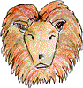
  - ? yes
  - ? no
- This is a sheep. 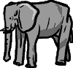
  - ? Yes
  - ? No
- This is a frog. 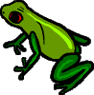
  - ? Yes
  - ? No
- This is a tiger. 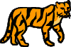
  - ? Yes
  - ? No
- This is a cow. 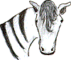
  - ? Yes
  - ? No

Look at the pictures. Look at the letters. Write the words.
1. e a k s n 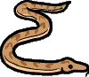
2. n c c k h e i 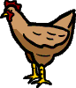
3. i r b d 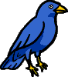
4. o d g 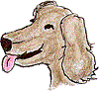
5. h f s i 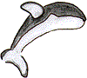
Read this. Choose a word from the box. Write the correct word in the gaps.
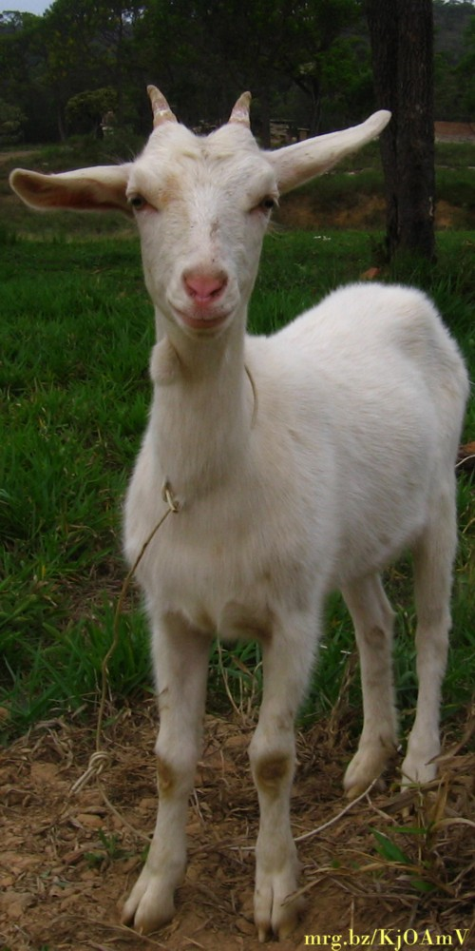
Hi! I am an which has four , and one . I don't like eating and . I am usually white.
Who am I?
Choose one of these words:
water, hamburgers, yellow, grass, boy, animal, eyes, ear, legs, mouths, fifteen, tail, coconuts
Look at the pictures and read the questions. Write one-word answers.
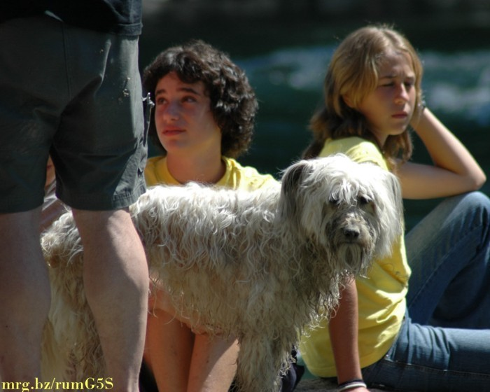
Questions:
1. How many people can you see in the photo ?
2. Which animal is in front of the girls ? A .
3. What is the colour of the girls' T-shirts ?
4. Are the girls standing or sitting ?
5. What colour is the dog ?

