SỞ GIÁO DỤC VÀ ĐÀO TẠO GIA LAI KÌ THI CHỌN HỌC SINH GIỎI CẤP TỈNH
LỚP 12 THPT
ĐỀ THI CHÍNH THỨC Môn thi: TIẾNG ANH
Thời gian: 180 phút (không kể thời gian giao đề)
(Đề thi gồm 12 trang)
Số phách
(do chủ tịch hội đồng chấm thi ghi)
…………………………
- Thí sinh không được sử dụng tài liệu, kể cả các loại từ điển
- Giám thị không được giải thích gì thêm

I. LISTENING (2.6 pts)

Part 1: Questions 1-7. There are seven questions in this part. For each questions there are three pictures and a short recording. Choose the correct picture and put a tick (✓) in the box below it.

Example: Where did the man leave his camera?

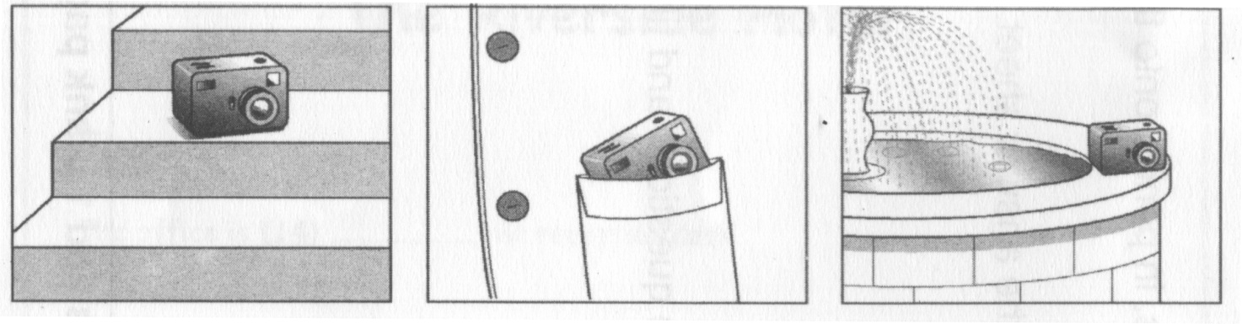
A  B ◻ C ◻
1. What do they order?

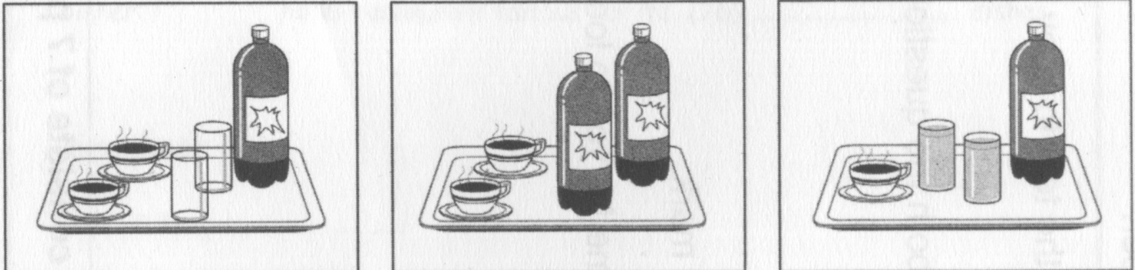
A  B ◻ C ◻

2. When will Pele come to pick Dave up?

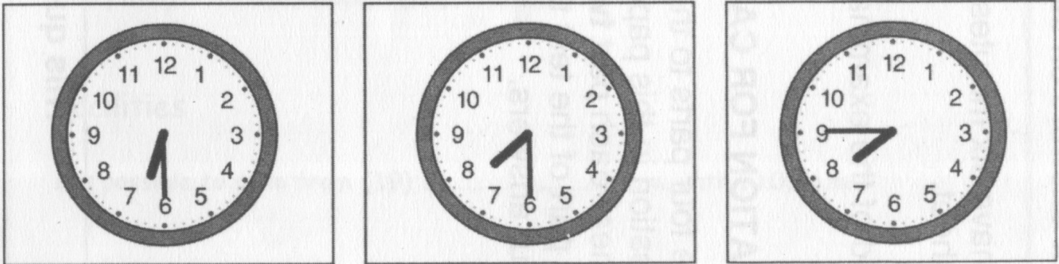
A ◻ B ◻ C 
3. How did the woman get home yesterday?

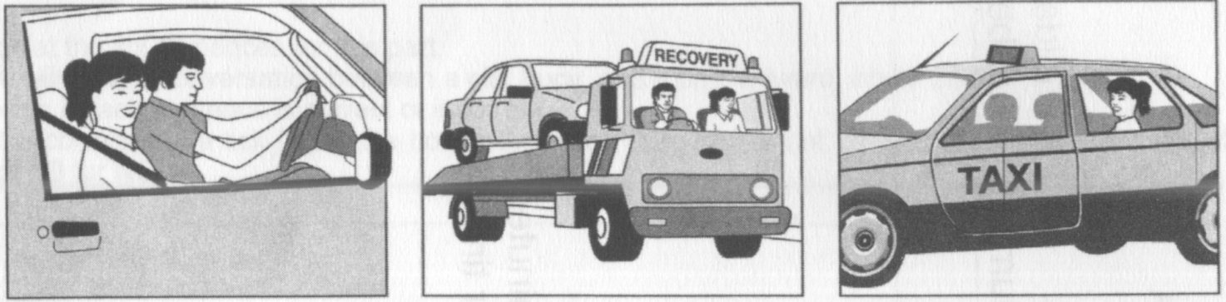
A  B ◻ C ◻

4. What does the woman describe to buy Tanya?

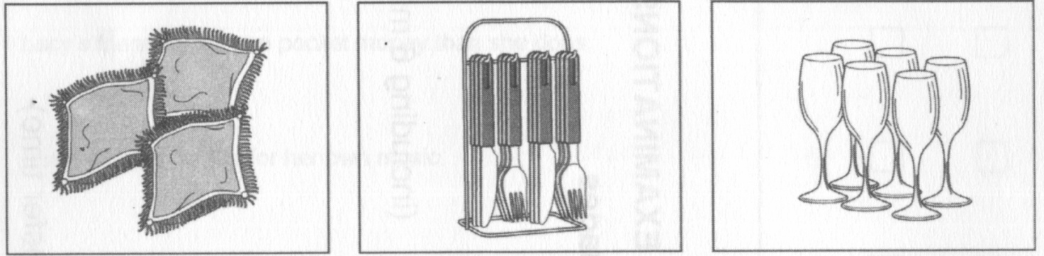
A  B ◻ C ◻

5. What does James do on his birthday?

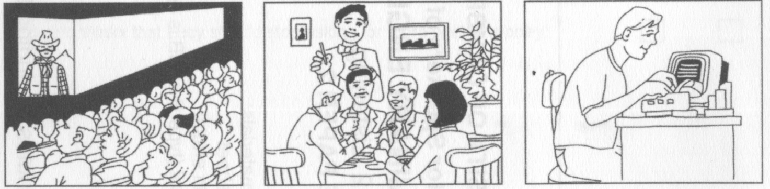
A  B ◻ C ◻

6. Where did the woman leave her notebook?

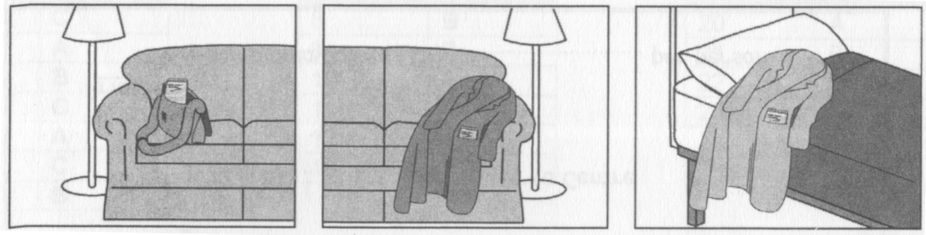
A ◻ B  C ◻

7. What will the man return to the library?

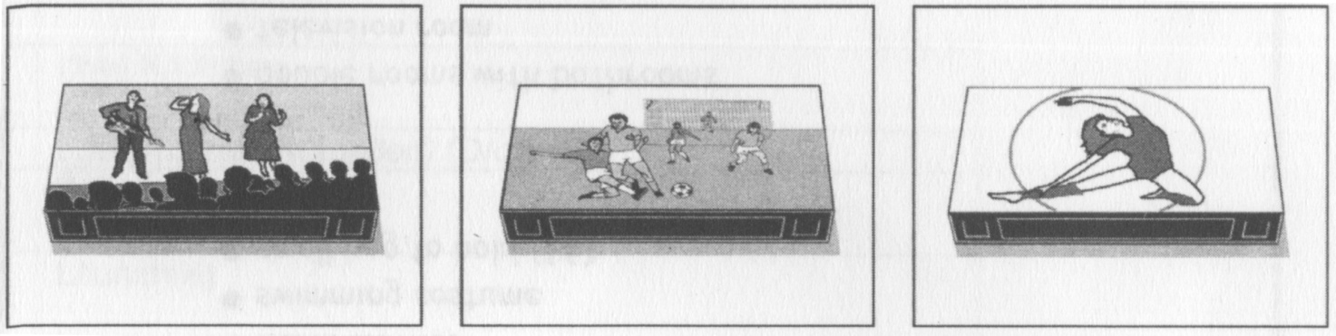
A ◻ B ◻ C 
Part 2: Questions 8-13. You will hear a woman called Lucy talking on radio about a new magazine. For each question, put a tick (✓) in the correct box.
8. What is Lucy’s main reason for starting a new magazine?
A. She was asked to do it. ◻
B. She wanted more writing experience. ◻
C. She wanted to produce her own magazine. 
9. The magazine is different to a local newspaper because of
A. What it looks like. ◻
B. What it contains. 
C. Where you can buy it. ◻
10. The first half of the magazine helps people to
A. choose leisure activities. 
B. keep up to date with world news. ◻
C. plan holidays around Britain. ◻
11. The restaurants in the reports are chosen because
A. readers recommend them. ◻
B. people have complained about them. ◻
C. the journalists have tried them. 
12. In the second half of the magazine you can find
A. reviews of local artists’ work. ◻
B. articles about local people. 
C. articles to help local businesses. ◻
13. What pleases Lucy about the magazine?
A. the high quality of the writers 
B. the attitude of the readers ◻
C. the variety of subjects covered ◻

II. LEXICO-GRAMMAR (9.4 pts)

Part 1: Choose the word or phrase which best completes each sentence. Write your answer (A, B, C, or D) in the numbered blanks provided below this part.
14. - That woman in the flat next door to mine is really miserable. She never even says hello to me.
- Oh, she _______ be quite nice sometimes, I’ve found.
A. can B. may C. might D. ought to
15. - Haven’t you finished this decorating yet?
- No, and I do think you _______ help me instead of just standing around.
A. may B. might C. please D. will
16. - No one will give me a job. What can I do?
- Well, you _______ go to an agency.
A. could B. may C. perhaps D. ought
17. ________ so incredible is that these insects successfully migrate to places that they have never even seen.
A. That makes the monarch butterflies’ migration
B. The migration of the monarch butterflies is
C. What makes the monarch butterflies’ migration
D. The migration of the monarch butterflies, which is
18. _______, methane can be used as a fuel.
A. It is produced by the fermentation of organic matter
B. Produced by the fermentation of organic matter
C. The production by the fermentation of organic matter
D. The fermentation of organic matter
19. When ________ is not known.
A. was the wheel invented B. the invention of the wheel
C. it was invented the wheel D. the wheel was invented
20. The confident trickster ________ the old lady out of her life savings.
A. swindled B. robbed C. deceived D. misled
21. The doctor was praised for her _______ work with her patients.
A. groundless B. tireless C. bottomless D. restless
22. It was with a ______ heart that she said goodbye to all her colleagues.
A. solemn B. heavy C. dismal D. grim
23. Psychologists still wonder if some personality traits are ________.
A. interminable B. inadvertent C. innate D. inevitable
24. As is known to all, everyone is born _______.
A. equal B. same C. similar D. alike
25. I was very angry because none of the servants was _______ when I wanted a message.
A. inaccessible B. fashionable C. illegible D. available
26. ______ little we may like it, old age comes to most of us.
A. So B. Since C. However D. Despite
27. When my mother was in hospital, I was busy so I had to see her not _______ but _______.
A. some day / every day B. every day / some other day
C. every day / every other day D. the other day / every day
28. She opened her mouth _______ and didn’t know what to say.
A. in no fear B. for fear C. in fear D. at fear
29. The post office that you are looking for is ________.
A. for distance B. at some distance
C. no distance D. both A and C are correct
30. After class they went to see Peter, who ______ a high fever.
A. was down with B. felt sick with C. was down into D. fell ill into
31. Peter was ______ to be the best basketball player by the students in his school.
A. acknowledged B. recognized C. admitted D. accepted
32. Our soldiers _______ bravely against the enemy.
A. proceeded B. forwarded C. advanced D. furthered
33. The rapid development of our hometown ________ a change in our opinion.
A. effected B. performed C. impacted D. suffered
Your answers:
14. ___A_______ 15. ___B_______ 16. ___A_______ 17. ___C_______
18. ___B_______ 19. ___D_______ 20. ___A_______ 21. ___B_______
22. ___B_______ 23. ___C_______ 24. ___A_______ 25. ___D_______
26. ___C_______ 27. ___C_______ 28. ___C_______ 29. ___C_______
30. ___A_______ 31. ___A_______ 32. ___C_______ 33. ___A_______

Part 2: Insert a / an or the, or Ø (zero article). Write your answer in the numbered blanks provided below this part.
It has been announced that for (00) ______ third consecutive month there has been (34) __________ rise in (35) __________ number of people unemployed, rather than (36) __________ fall that had been predicted. The rise was blamed on (37) __________ continuing uncertainty over (38) __________ government economic policy, and couldn't come at (39) __________ worse time for the Prime Minister, who is facing (40) __________ growing criticism over (41) __________ way (42) __________ present crisis is being handled.
MPs are increasingly voicing (43) __________ fears that despite (44) __________ recent devaluation of the pound and cuts in (45) __________ interest rates, (46) __________ government still expects (47) __________ recovery of the economy to take three or even four years. To make matters worse, (48) __________ number of small businesses going into (49) __________ liquidation is still at a record level, and (50) __________ housing market is showing no signs of recovery. Some backbenchers expect a general election before (51) __________ end of the winter unless there is (52) __________ rapid change of (53) __________ fortune.
Your answers:
(00). ___ the __
34. ____a______ 35. _____the_____ 36. ____the_____ 37. ____the_____
38. ____ Ø _____ 39. _____a_____ 40. ____ Ø ______ 41. ____the_____
42. ____the_____ 43. ____ Ø ______ 44. ____the_____ 45. ____ Ø _____
46. ____the_____ 47. _____the____ 48. ____the_____ 49. ____ Ø _____
50. ____the_____ 51. _____the____ 52. _____a_____ 53. ____ Ø _____

Part 3: In most lines of this text there is one unnecessary word. It is either incorrect grammatically, or does not fit the sense of the text. For each line write the unnecessary word in the space beside the text. Tick each correct line.
The term 'drugs' covers many of kinds of chemical substance 00 ______of_______
which they are absorbed by the body, the majority being 00 ______they ____
medicines designed to cure illnesses. They are manufactured 00 ________✓______
from a variety of sources which include animal and products, 54 ____ and ________
plants and minerals. In the recent years it has become possible 55 _____the ________
to synthesize in the laboratory many drugs which previously 56 _____which _____
obtained from plants and animal products. A small number of 57 _____✓_________
drugs can become addictive if taken excessively, as that is either 58 _____as _________
too frequently, or in doses larger than they recommended for 59 _____they _______
medical to use. Drugs intended as painkillers, or drugs with a 60 _____to _________
hypnotic effect are used as sleeping pills, can both become 61 _____are ________
addictive if abused. It is important to make emphasize the fact 62_____make ______
that it is the abuse of drugs which has once become a widespread 63 _____once ______
social problem in many societies, and not that the drug itself 64 ______not ______
may have many of beneficial effects when used medically. This is 65 ______of ________
why many drugs are obtainable only through prescription from 66 _______✓________
a doctor. Some people would argue that if addiction to drugs 67 _______if ________
involves both psychological and social factors, since those are 68 ______are _______
people who become addicts may do so as in order to find some 69 _______as _______
relief from personal or social inadequacies. This argument 70 _______✓_______
implies that it is somehow the addict's fault if not he or she 71 _______not ______
becomes addicted, and this is it to ignore the powerful physical 72 _______it _______
effects of many drugs. Any temporary effects of the well-being 73 _______the ______
soon wear off, leading to severe physical discomfort.

Part 4: Complete the text with a suitable preposition in each space. Write your answer in the numbered blanks provided below this part.
David Peters, the Scottish long-jumper, has been awarded a knighthood in recognition (00) _____ his services to charity and the world of athletics. Sir David, as he will be known, will be knighted by the Queen in a ceremony next week. Mr Peters, who retired from athletics last year, had a talent which was, quite simply, (74) ____of the ordinary. All his performances were, (75) ____exception, characterized by great effort and determination. He seemed to thrive on difficult situations, and it was when (76) ____ pressure, that he produced his greatest performances. In later years, he became increasingly prone (77) ____injury, and last year, his talents evidently (78) ____ decline, he failed to regain his Olympic long-jump title, and promptly retired. At his best, however, his jumping was sometimes (79) ____ belief, and in his greatest year, 2000, he broke the world record no fewer than four times. In the late 1990s he was single-handedly responsible (80) ____ bringing British athletics out of a severe slump with his inspirational performances and personal charisma. Peters was capable (81) ____ great generosity, and once, famously, failed a jump deliberately in order to let his great rival, Aravan Sijipal, win on his farewell appearance. When being interviewed, Peters was also an exception to the rule, for he always tried to praise others rather than blow his own trumpet. A deeply religious man, he was (82) ____ dispute with the athletics authorities on more than one occasion for his refusal to compete on Sundays. His anti-drugs campaign had a great effect (83) ____ young athletes all over Britain, and throughout his career, he remained very conscious (84) ____ what he saw as his public duty in this respect. Many charitable organizations have reason to be grateful (85) ____ him (86) ____ the time he devoted to raising money for their causes.
Your answers:
(00). __of____ 74. ____out______ 75. ___without____ 76. ___under___
77. ___to_____ 78. ____in____ 79. ___beyond____ 80. ___for_____
81. ___of_____ 82. ____in____ 83. ____on____ 84. ___of____
85. ___to____ 86. ____for____
Part 5: Put the verbs in brackets in correct tense and form. Write your answer in the numbered blanks provided below this part.
ARE COMPUTERS GOOD EDUCATORS?
Computers (87) _____ (become) more and more prevalent in our schools, even five-year-olds are learning how to use them. Many child development experts are worried that computers may deprive children of their childhood by pushing them into formal education too early in life. Most people would agree, however, that it s too soon to know how computers (88) _____ (affect) the education of children.
Interviewer: Should computers (89) _____ (encourage) in schools?
Reply 1: We (90) ____ (have) many other fads in education, like tape recorders and TV, and these things were not the salvation of our schools. The computer is just another fad. It’ll die out in a few years, you (91) _____ (see)
Reply 2: So far, computers (92) _____ (use) mostly for drill work, and do drills is not the best way to learn. I’m against using computers in schools unless some more imaginative uses (93) _____ (find) for them.
Reply 3: If you (94) _____ (start) children with computers too early, the computer (95) _____ (control) the children. Children need to be active and outdoors, they don’t need to be silently (96) ______ (hook) to a computer.
Reply 4: As long as children get a balanced education, I see nothing wrong with (97) _____ (encourage) children to learn to use computers in school.
Your answers:
87. are becoming / have been becoming 88. will affect
89. be encouraged 90. had
91. will see 92. have been used
93. are found 94. start
95. will control 96. hooked 97. encouraging
Part 6: Write the correct form of each bracketed word in the numbered spaces provided in the space provided under this part
Antonio Vivaldi, an Italian composer and a violinist, was the most (98) ____ (influence) of his age. He was born March 4, 1678, in Venice, and was trained by his father, a violinist at Sa Mark’s Cathedral. (99) ____ (ordain) a priest in 1703, Vivaldi began teaching that year at the Ospedale della Pietà, a (100) _____ (conserve) for orphaned girls. He was associated with the Pietà, usually as music (101) ____ (direct), until 1740, training the students, composing concertos and oratorios for (102) _____ (week) concerts, and meanwhile establishing an international reputation. From 1713 on, Vivaldi was also (103) _____ (act) as an opera composer and producer in Venice and traveled to Rome, Mantua, and (104) _____ (else) to oversee performances of his operas. In about 1740 he accepted a position at the court of Empire Charles VI in Vienna. He died in Vienna on July 28, 1741.
Vivaldi’s concertos provided a model for this genre throughout Europe, affecting the style even of his older contemporaries. Vivaldi was the first composer who (105) ____ (consistent) used the ritornello form that became standard for the fast movements of concertos. The ritornello was a section that recurred in (106) _____ (differ) keys and was played by the full orchestra. It alternated with soloist-dominated sections (episodes) that in his works were often virtuosic in character. He virtually established the three-movement format for the concerto and was among the first to introduce cadenzas for soloists. His opus 8 concertos entitled The Four Seasons are early examples of (107) ____ (orchestra) program music. Like much of his music, they are marked by vigorous rhythms and strong contrasts.
Your answers:
98. influential 99. ordained 100. conservatory
101. director 102. weekly 103. active
104. elsewhere 105. consistently 106. different
107. orchestral

III. READING (4 pts)

Part 1: Read the passage and then decide which word best fits each space. Circle A, B, C or D to indicate your answer.
The heart has long been considered to be where feelings of love (108) ______. In love songs throughout the ages, love almost always (109) ______ together with the heart. The heart has continuously been viewed as the place where love begins and (110) _______. Even the Bible gives numerous (111) _______ to love and the heart.
The role of the heart in love must come from what happens to it when a person feels strongly (112) ________ to someone else. The strong feelings for the other person, especially in the early stages of a (113) _______, have the results that the heart starts beating faster and breathing starts (114) ______ up.
According to psychologists, a love relationship is a situation that involves a lot of stress and the body (115) _______ to this by getting ready to face the unknown. This has been called the “fight or flight” reaction, meeting danger by (116) ______ it or running away. So with love, the heart accelerates and (117) _______ becomes quick.
108. A. dwell B. stay C. remain D. linger
109. A. moves B. associates C. goes D. combines
110. A. prospers B. seeps C. develops D. grows
111. A. preferences B. references C. citation D. quotes
112. A. attracted B. attached C. bond D. linked
113. A. relationship B. connection C. binding D. link
114. A. going B. showing C. speeding D. beating
115. A. answers B. reacts C. replies D. looks
116. A. battling B. struggling C. defeating D. fighting
117. A. exhaling B. inhaling C. perspiring D. breathing

Part 2: You are going to read a magazine article about friends. Seven sentences have been removed from the article. Choose from the sentences A- H the one which fits each gap (118- 123). There is one extra sentence which you do not need to use. There is an example at the beginning (000).
A. It’s unwise to isolate yourself when you’re in a boy / girl relationship.
B. Suppose you’re going through a bad patch with your boyfriend or girlfriend.
C. It’s stimulating to be surrounded by a mix of personalities with their different attitudes and behavior.
D. Even your best friend may get jealous if they feel pushed out by your girlfriend or boyfriend.
E. There might well be some more reserved characters too.
F. To the majority of us this is someone we trust completely and who understands us better than anyone else.
G. Or they may be someone you meet by chance and instantly get on with.
H. There are all sorts of things that can bring about this special relationship.
FRIENDS
To many people, their friends are the most important thing in their life. Really good friends share the good times and the bad times, help you when you’ve got problems, never judge you and never turn their backs on you. Your best friend may be someone you’ve known all your life, someone you’ve grown up with and been through lots of ups and downs with.
(000). __H__ It may be the result of enjoying the same activities, having the same outlook on life, or sharing similar experiences. Most of us have met someone that we’ve immediately felt relaxed with, as if we’ve known them for years. But usually it really does take years to get to know someone well enough to consider them your “best friend”.
118. ___F____It’s the person you can turn to for impartial advice and a shoulder to cry on when life lets you down. You know that no matter what the problem or what time of day or night it is, your best friend will drop everything and put you first. No relationship is more important than the one with your best friend.
119. ___B____It will probably be your best friend you go to for help. Perhaps your parents are being too heavy-handed; maybe you’re not happy at work or at school. Whatever the problem, you know you can rely on your best friend.
Of course, not all friendships stand the test of time. All sorts of things can come between friends. Sometimes people just drift apart over time. One of you may leave the area and you simply lose touch. But sometimes other relationships can conflict with your friendship and cause powerful emotions.
120. ___D____If they do and you want to keep them, it’s important to make them feel valued. Set aside some time to go out with them on your own, or introduce them to your new boyfriend or girlfriend, and do things together.
121. ___A____If you do, you may find that one day you break up and you’ve lost touch with all your old friends. And besides, it’s fun to go out in groups, especially when you’re young.
122. ___C____People who you might not expect to get on with each other can often make a good combination. Usually in a particular group of friends there’ll be a ringleader, someone the rest look to to make decisions. Often there’s a bit of a comedian, always cracking jokes and entertaining the rest.
123. ___E____They all have something to contribute. Remember, unlike your family, you can choose your friends. If you choose them carefully and treat them well, they could turn out to be friends for life.

Part 3: Read the passage and choose the best answer to each question from the four choices given. Circle A, B, C or D to indicate your answer.
Until recently, women in advertisements wore one of three things- an apron, a glamorous dress or a gown. Although that is now changing, many women still feel angry enough to deface offending advertisements with stickers protesting “this ad degrades women”. Why does this sort of advertising exist? How can advertisers and ad agencies produce, sometimes after months of research, advertising that offends the consumers?
The Advertising Standards Authority (the body which deals with complaints about print media) is carrying out research into how women feel about the way they are portrayed in advertisements. Its conclusions are likely to be what the advertising industry already knows: although women are often irritated by the way they are seen in ads, few feel strongly enough to complain.
Women are not the only victims of poor and boring stereotypes-in many TV commercials, men are seen either as useless, childish oafs who are unable to perform the simplest household tasks, or as inconsiderate boors, permanently on the lookout for an escape to the pub. But it is women who seem to bear the brunt of the industry’s apparent inability to put people into an authentic present-day context.
Yet according to Emma Bennett, executive creative director of a London advertising agency, women are not infuriated by stereotypes and sexist advertising. “It tends to wash over them; they are not militant or angry-they just find it annoying or tiresome. They reluctantly accept outdated stereotypes, but heave a sigh of relief when an advertising really gets it right.” She says that it is not advertising’s use of housewife role that bothers women, but the way in which it is handled. “Researchers have often asked the wrong questions. The most important thing is the advertising’s tone of voice. Women hate being patronized, flattered or given desperately down-to-earth commonsense advice.”
In the end, the responsibility for good advertising must be shared between the advertiser, the advertising agency and the customer. Advertising does not set trends but it reflects them. It is up to the consumer to tell advertisers where they fail, and until people on the receiving end take the business seriously and make their feelings known, the process of change will remain laboriously slow.
124. Despite recent changes in attitudes, some advertisings still fail to ____________.
A. change women’s opinions of themselves
B. show any understanding of people’s feelings
C. persuade the public to buy the advertising industry
D. meet the needs of the advertising industry
125. According to the writer, the commonest fault of present-day advertising is to ___________.
A. condemn the role of housewife B. ignore protests about advertisements
C. present a misleading image of women D. misrepresent the activities of men
126. Research suggests that the reaction of women towards misrepresentation by advertisements is __________.
A. apathy B. hostility C. approval D. relief
127. Emma Bennett suggests that advertisements should __________.
A. give further emphasis to practical advice.
B. change their style rather than their content
C. use male images instead of female ones
D. pay more compliments to women than before
128. Ultimately the advertising industry should _________.
A. take its job more seriously B. do more pioneering work
C. take notice of public opinion D. concentrate on the products advertised

Part 4: Fill in each numbered blank with ONE suitable word. Write your answer in the numbered blanks provided below this part.
All drugs can affect the body (000) ____ both helpful and (129) _____ ways. For example, a particular drug may produce a stronger heartbeat (130) ______ from pain, or some other desired effect. But that drug, (131) ______ any other drug, can also cause undesired effects – especially if the (132) _____ is too large. Such effects might (133) _____ fever, high blood pressure, or constipation.
Most drugs produce changes throughout the body because the drugs (134) _____ through the blood stream. (135) ____ most drugs used to affect one part of the body also affect other parts. For example, physicians sometimes (136) _____ morphine to relieve pain. Morphine depresses the activities of cells in the brain and thus reduces the (137) _____ of pain. But morphine also alters the function of cells elsewhere in the body. It may decrease the rate of breathing, produce constipation, and (138) _____ other undesired effects.
Your answers:
(000). __in_______ 129. __harmful _____ 130. __relief _____
131. ___like________ 132. __dose ________ 133. __include___
134. ___circulate ____ 135. ___ so/therefore/thus ___ 136. __ prescribe __
137. __ sensation _______ 138. ___create___

Part 5: Choose each of the following words or phrases in its correct place in the passage below. Write your answer in the numbered blanks provided below this part.
male chauvinist second-class citizens male-dominated discrimination
militant unisex feminist sexist
sex-objects exploitation the weaker sex

A (000) ______ is a person, usually a woman, who believes that women should be regarded as equal to men. She, or he, deplores (139) _____ against women in the home, place of work or anywhere, and her principal enemy is the (140) _____, who believes that men are naturally superior. Tired of being referred to as (141) _____ women are becoming more and more (142) _____ and are winning the age-old battle of the sexes. They are sick to death of (143) _____ jokes which poke fun at women. They are no longer content to be regarded as (144) ______ in terms of economic, political and social status. They criticize beauty contests and the use of glamorous female models in advertisements, which they describes as the (145) ______female beauty, since women in these situations are represented as mere (146) _____. We no longer live in the (147) _____ societies of the past. Let us hope, however, that the revolution stops before we have a boring world in which sex doesn’t make much difference. We already have (148) _____ hairdressers and fashions. What next?
Your answers:
(000). _ feminist __ 139. discrimination 140. male chauvinist
141. the weaker sex 142. militant 143. sexist
144. second-class citizens 145. exploitation 146. sex-objects
147. male-dominated 148. unisex

IV. WRITING (4 pts)

Part 1: Finish each of the following sentences in such a way that it means exactly the same as the sentence printed before it
149. It seems that no one predicted the correct result.
No one seems to have predicted the correct result.
150. She didn’t inherit anything under her uncle’s will.
Her uncle didn’t leave her anything in his will.
151. The dress was so tempting that I bought it.
I couldn’t resist the temptation to buy the dress.
152. We discussed the business at length, but came to no decision.
We had a long discussion about the business but came to no decision.
153. You may get hungry on the train, so take some sandwiches.
In case you get hungry on the train, (you should/had better) take some sandwiches.

Part 2: Rewrite the following sentences, using exactly the words given
154. When Mary was pregnant, all she wanted to eat was jelly.
CRAVING Marry had a craving for jelly when she was pregnant.
155. The interview panel thought that Sarah had a very good manner.
IMPRESSION Sarah made a very good impression on the interview panel.
156. Organic vegetables are said to be healthy.
WONDERS organic vegetables are said to do wonders for your health.
157. The fact that he will never race again is something he cannot accept.
TERMS He cannot come to terms with the fact that he will never race again.
158. Pandas need a special diet, without it they perish.
PROVIDED Provided (that) pandas have a special diet, they survive.

Part 3: Study the chart carefully then write a paragraph of about 150 words, describing the information in the chart.
…………………………………………………………………………………………………………
…………………………………………………………………………………………………………
…………………………………………………………………………………………………………
…………………………………………………………………………………………………………
…………………………………………………………………………………………………………
…………………………………………………………………………………………………………
…………………………………………………………………………………………………………
…………………………………………………………………………………………………………
…………………………………………………………………………………………………………
…………………………………………………………………………………………………………
…………………………………………………………………………………………………………
…………………………………………………………………………………………………………
…………………………………………………………………………………………………………
…………………………………………………………………………………………………………
…………………………………………………………………………………………………………
…………………………………………………………………………………………………………
…………………………………………………………………………………………………………
…………………………………………………………………………………………………………
…………………………………………………………………………………………………………
…………………………………………………………………………………………………………
…………………………………………………………………………………………………………
…………………………………………………………………………………………………………
…………………………………………………………………………………………………………
…………………………………………………………………………………………………………
…………………………………………………………………………………………………………
…………………………………………………………………………………………………………
…………………………………………………………………………………………………………
…………………………………………………………………………………………………………
…………………………………………………………………………………………………………
…………………………………………………………………………………………………………
…………………………………………………………………………………………………………
…………………………………………………………………………………………………………
…………………………………………………………………………………………………………
……………………………………………………………………………………………………………………………………………………………………………………………………………………
…………………………………………………………………………………………………………
…………………………………………………………………………………………………………
…………………………………………………………………………………………………………
…………………………………………………………………………………………………………
…………………………………………………………………………………………………………
…………………………………………………………………………………………………………
…………………………………………………………………………………………………………
…………………………………………………………………………………………………………
…………………………………………………………………………………………………………

…………………………………………………………………………………………………………
…………………………………………………………………………………………………………
…………………………………………………………………………………………………………
…………………………………………………………………………………………………………
…………………………………………………………………………………………………………
…………………………………………………………………………………………………………
……………………………………………………………………………………………………………………………………………………………………………………………………………………
…………………………………………………………………………………………………………
…………………………………………………………………………………………………………
…………………………………………………………………………………………………………
…………………………………………………………………………………………………………
…………………………………………………………………………………………………………
…………………………………………………………………………………………………………
…………………………………………………………………………………………………………
…………………………………………………………………………………………………………
…………………………………………………………………………………………………………
…………………………………………………………………………………………………………
…………………………………………………………………………………………………………
…………………………………………………………………………………………………………
…………………………………………………………………………………………………………
…………………………………………………………………………………………………………
…………………………………………………………………………………………………………WHITE LIES
Very (6) __________, newborn babies are not beautiful. They are wrinkled or bald, or they have an angry (87) __________ on their faces that seems to say, "Go away! I (88) __________everybody." But (89) __________ a parent, that bald, wrinkled, mean-faced baby is the most beautiful and perfect child in the world. When that proud father or mother asks you, "Well, what do you think - isn't she beautiful?" what are you going to (90) __________? Is this the time for the truth? Of course (91) __________!
You look that proud father in (92) __________ eye and say, "Yes, she is! She's a (93) __________ beauty. She's one in a million. She's going to be a movie star! I can tell! She's as pretty as a (94) __________."
This is what we (95) __________ in English a white lie. White lies don't hurt people; they aren't cruel or angry words. People use them to make a difficult situation (96) __________ easier. When people {97) __________ dates, forget their homework, or taste something new that they don't (98 __________ like while eating at a friend's house, they tell a white lie. They are trying to be kind. They don't want to (99 __________ someone's feelings. It is important to be honest. But many people feel that being kind and (100) __________ is sometimes more important.
86. A. often  87. A. impression  88. A. feel hate  89. A. for  90. A. say  91. A. neither  92. A. his  93. A. genuine  94. A. flower  95. A. name  96. A. far  97. A. refuse  98. A. genuinely  99. A. hurt  100. considered | B. usually  B. looking  B. am hating  B. to  B. tell  B. no  B. an  B. real  B. fairy  B. call  B. more  B. reject  B. especially  B. wound  B. considering | C. Occasionally  C. Appearance  C. hate  C. with  C. speak  C. never  C. the  C. true  C. painting  C. express  C. a little  C. deny  C. particularly  C. damage  C. considerable | D sometimes  D expression  D can hate  D as for  D utter  D not  D one  D exact  D picture  D know  D little  D disregard  D specially  D injure  D considerate

Directions: choose the word or phrase that best completes each unfinished sentence below or that best keeps the meaning of the original sentence if it is substituted for the underlined word or phrase.
1- He passed the test by the skin of his teeth. (một cách suýt sóat)
A. easily B. with very little margin C. with a very high score D. All are correct
2- By the way, Henry, did you have any lunch? (nhân tiện, tiện thể)
A. Suddenly B. Once and for all C. Incidentally D. Definitely
3- It has rained for four days without letting up. (giảm bớt, dịu đi)
A. thundering B. freezing C. increasing in intensity D. slackening
4- His offer took everyone by surprise. (làm ai ngạc nhiên)
A. surprised everyone B. was different from others
C. was similar to others D. made everyone angry
5- Susan broke her promise when she failed to return the book. (không giữ đúng lời hứa)
A. kept to herself B. had an appointment
C. lost her friend D. failed to do what she said
6-I have suspected the hostess of lying for a long time, and today we are going to have it out with her. (tranh cãi)
A. cheat B. quarrel with C. talk with D. defend
7- Their attorney (luật sư) has promised to hold off legal action for another week. (hoãn lại)
A. cancel B. call off C. delay D. give out
8- His secretary took down everything that we said. (viết tốc ký)
A. forgot B. wrote in shorthand C. discarded D. remembered
9-The finance company seized (tịch thu) his car because he fell behind in his payments. (Trả không đúng hạn, còn thiếu lại)
A. didn't pay his debt B. didn't want to pay the balance
C. didn't pay taxes D. failed to keep up in his payments
10-Completely surrounded by our troops, the enemy finally gave in.
A. surrendered B. declared war C. ran away D. retreated
11-Although we suspected that he was guilty, he went scot-free. (trót lọt, không bị phạt)
A. was fined B. was freed without any fine
C. was released from prison D. was not charged with murder
12-He was received by the family with open arms. (rất nồng nhiệt)
A. carelessly B. with warm welcome C. casually D. reluctantly
13-Although he behaved like a gentleman, he was a wolf in sheep's clothing. (kẻ lừa dối)
A. famous person B. kind - hearted person C. deceiver D. very important person
14-Irene tells us word for word what happened. (một cách chính xác)
A. secretly B. exactly C. in a whisper D. carelessly
15-Mr. Scott worked his way up from office boy to president. (thăng tiến)
A. advanced himself B. took care of himself C. worked hard D. promoted
16-The letter we expected has gone astray. (thất lạc)
A. arrived B. gotten lost C. disappeared D. appeared
17-If you can finish it by noon, go ahead. (tiếp tục, làm tiếp)
A. proceed B. turn on C. keep on D. go away
18-Shall we go fifty-fifty with the prize money? (chia đều)
A. share equally B. get even C. spend together D. get square
19-I saw stars when I hit my head against the door. (choáng váng)
A. became dizzy B. passed out C. fainted D. cried
20-She will never set foot in my house. (gia nhập, vào)
A. clean B. enter C. buy D. demolish
21 -John and Grace settled down in their new home. (ổn định cuộc sống)
A. had a quarrel B. lived a normal life C. had a row D. lived expensively
22-He has shifted for himself since he was 21 years of age. (tự xoay sở, tự chăm sóc)
A. been disabled B. bathed by himself
C. taken care of himself D. been in the hospital
23-The bobby - soxers applauded their favorite actor. (cô gái đang tuổi thanh niên)
A. niggers (ngời da đen)B. spendthrifts (người ăn tiêu hoang phí) C. adolescent girls D. misers
24-We have been bosom friends for many years. (bạn thân)
A. old friends B. good friends C. pen - friends D. close friends
25-The police ran after the thief and finally caught him. (đuổi theo)
A. chased B. intercepted C. talked with D. questioned

Many passengers were aboard the night it rammed an iceberg, only two days at sea and more than half way between England and the New York destination. Because the luxury liner was traveling so fast, it was impossible to avoid the ghostly looking iceberg. An unextinguished fire also contributed to the ship's submersion. Panic increased the number of casualties as people jumped into the icy water or fought to be among the few to board the lifeboats. Four hours after the mishap, another ship, the Carpathia, rescued the survivors-less than a third of those originally aboard.
The infamous Titanic enjoyed only two days of sailing glory on its maiden voyage in 1912 before plunging into 12,000 feet of water near the coast of Newfoundland, where it lies today.
31 - Which of the following is not true?
A. The Carpathia didn't rescue the survivors. B. The Carpathia rescued the survivors.
C. The Titanic sank near Newfoundland. D. The Titanic was the fastest ship afloat in 1912.
32 - Which of the following did not contribute to the large death toll?
A. panic B. fire C. speed D. Carpathia
33 - How many days was the Titanic at sea before sinking?
A.I B. 3 C.4 D.5
34 - The word "unexfingitished" means most nearly the same as____.
A. unpreventable B. uncontrollable C. undiscovered D. unquenched
35 - A ship 's maiden voyage is _______.
A. its first voyage B. its last voyage C. its crew D. its engine room

IV. Fill in each numbered blank with ONE suitable word
The causes of headaches, (26) _whether_ they are the common kind of tension or migraine headaches, or any other kind, are usually the same. During period of stress, muscles in the neck, head, and face are contracted (27) _so_ tightly that they exert tremendous pressure (28) _on_ the nerves beneath them. Headaches take many forms from a constant, dull pain to an insistent hammering.
Although at (29) _least_ 50% of American adults are estimated (30) _to_, suffer one or more headaches per week, it is the 20 million migraine sufferers (31) _who_are in special difficulties. Migraines, which are mostly suffered by women, can involve tremendous, unrelieved pain.
Migraines, which may also (32) _be_ caused by stress, can occur in people who bottle up their emotions and who are very conscientious in their performance. Escaping (33) _from_ stressful situation, (34) _being_open with one's feeling, and lowering one's expectations can help reduce the stress and so cut down on those headaches which cannot be "help" aspirin an (35) _other_ non-prescription painkillers.
V. Read the passage carefully and then answer the questions
What is the most widely spoken language in the world today? Well, if you mean what language is spoken as a first or second language by the most people and what language is spoken in the greatest number of countries, then the answer is English.
An estimated billion and a half people in the world speak English. One hundred years ago, the original editor of the Oxford English Dictionary launched in appeal in Britain, the United States and the former British Empire for new words. Since the end of the 20th century, English has become the most widely used language around the world, and the editor of the OED, as the Oxford English Dictionary commonly called, are sending out a worldwide appeal as they begin the task of completely revising the OED.
The Oxford English Dictionary is widely regarded as the definitive record of the English language. Now the expansive twenty-volume dictionary is to be update and the publisher is calling on the English-speaking world to help. The English language has expanded greatly in recent years with new words, forms of uses in meaning flooding the language from around the world. The OED's principal word expert Admin Dvina said that the search for new words is being launched globally, simply because English is a worldwide language.
Contributors are invited to submit printed evidence of new words from a variety of sources, including magazines, newspapers, books and song lyrics; Dictionary editors are also keen to receive words of earlier centuries that have so far escaped inclusion.
36. Which language is considered the most widely spoken in the world today?
a. French b. English c. Japanese d. Russian
37. When did the original editor of the Oxford English Dictionary launch in appeal in Britain, the United States and the former British Empire for new words?
a. At the end of the 20th century. b. At the beginning of the 21st century.
c. One hundred years ago. d. In 2002.
38. Why did they send out an appeal for new words?
a. Because they wanted to begin the task of completely revising the OED.
b. Because English have not been spoken any longer.
c. Because they were afraid that English would be dominated by French.
d. All are correct
39. Why did they send out an appeal for new words globally?
a. Because they were forced to do so.
b. Because the Oxford English Dictionary editor could not do the task himself.
c. Because of the fame of them
d. Because English is a worldwide language.
40. Which sentence is not true?
a. New words that have been sent to Oxford English Dictionary need printed evidence.
b. In the Oxford English Dictionary, there are not words used in songs.
c. The Oxford English Dictionary has twenty volumes.
d. Dictionary editors are also keen to receive words of earlier centuries.

