………… Primary School THE FIRST SEMESTER TEST.
Marks

Name:………………………… Class: 5…. (School year:2012-2013).

I. Complete each word below each picture(2 pts). Hoàn thành từ dưới mỗi tranh

 |  | 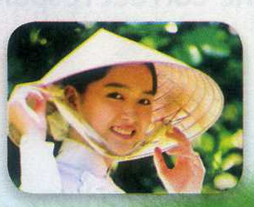 | 
1. sw_ m | 2. ch_ ss | 3. Vietnam_ _ _ | 4. . dr_ w
1/ swim 2/ chess 3/ Vietnamese 4/ draw

II. Look at the picture and complete the sentence(3 pts).Nhìn tranh và hoàn thành câu.
1. What does he do? 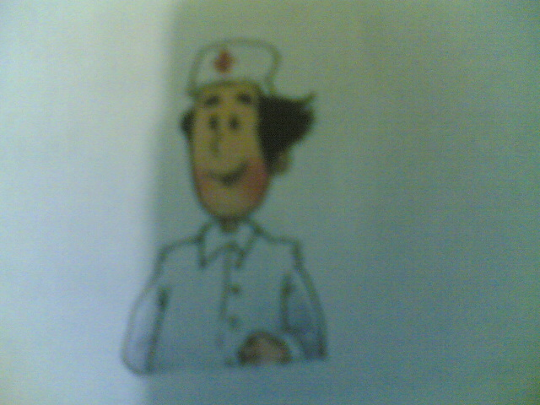
He is a ……………. doctor
2. Where is Nam from? 
He’s from …………. Vietnam

3. When was you born?
I was born on ……………….. fifth. 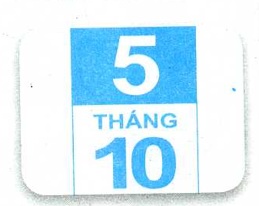
October
III. Select and circle the best answer A,B or C ( 3 pts ) Chọn và khoanh tròn đáp án đúng nhất A, B hay C
- What……………you do yesterday?
A. did B. do C. are
- What …………you doing now?
A. did B. do C. are
- What…………..your father do ? - He’s a doctor.
A. did B. does C. is
- I’m from London. I’m……………………………
A. England B. English C. American
- She is………………to music.
A. listen B. listening C. listened.
- We were……………the song Festival yesterday.
A. in B. on C. at
IV. Reorder the words to make sentences: (2 pts)Sắp xếp từ thành câu
1. are / rope / we / skipping .
__________________________________
2. was / I / born / on / October 3rd.
__________________________________
1/ We are skipping rope.
2/ I was born on October 3rd.

