Đề thi tiếng anh
Leave me out.
Take a redundant letter out from each word to make it correct
m a t a c h → o f f l i c e →
f i n d g e r → m u i l k →
a d d r e s t s → j u d i c e →
d r i e n k → e n g o l i s h →
e a s a y → r o w u n d →
Section 7: Safe Driving
Answer the question.
1. I am tired because I have to _ _ the housework all day.
2. George eats too much so he's getting _ _ _ .
3. What _ _ _ _ do you get up? - I get up at 7 a.m.
4. Let's play hide-_ _ _ -seek.
5. We danced, sang ang t_ _ _ stories in English.
6. His job is great because he can meet a _ _ _ of people.
7. We had celebrations _ _ the schoolyard.
8. They are rich _ _ they don't have to work.
9. Kate and I are reading books _ _ _ _ _ pets.
10. Are the students _ _ _ _ _ _ _ _ _ to music? No, they're playing volleyball.
11. I can do nothing at all. I _ _ _ _ a lot of work today.
12. Jenny's parents _ _ _ working for Legend Company.
13. Sally doesn't want to eat hamburgers any _ _ _ _ .
. 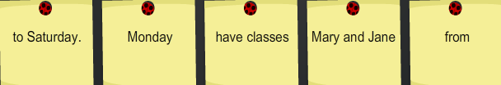

2. 

3. 

4. 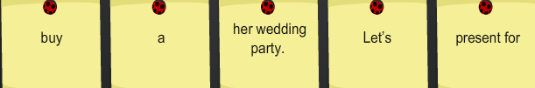

Khoanh vào chữ đặt trước câu trả lời đúng.
1/ Is your …… name Nguyen Thanh Huyen?- No, it’s Tran Thanh Huyen.
a. middle b. first c. family d.full
2/Linda is calling and Emma is …… the telephone.
a. speaking b. telling c.answering d.saying
3/Odd one out:
a. piano b. guitar c.singer d.violin
4/Red is my….. colour.
a.favourite b.interesting c.beautiful d.like
5/Would you like to play basketball?-……Good idea!
a.I like b.I love it c,I’d love to d.I want
6/Excuse me.Can I sit here?-……….
a.Sure! b.Here you are! c.Yes,I can. d.I’m sure
7/I’d like to send this letter…. England.
a.to b.on c.in d.at
8/Ann and her brother…… at home yesterday
a.didn’t are b.wasn’t c.weren’t d.not were
9/Choose the word that has the underlined part pronounced differently:
a.wet b.chess c.yesterday d.pretty
10/Odd one out:
a.playing b.learning c.writing d.evening
11.Don’t let your brother… the present.
a.to see b.seeing c.see d.sees
12.How…do you study in the school library?-Every afternoon.
a.usually b.never c.sometimes d.often
13.We are…work at the moment.
a.on b.in c.at d.with
14.What is Elena’s date of bith?-…..
a.September 2nd b.September and 2nd c.2nd and September d.September 2
15.Why does Alex go to the….?-Because he has a toothache.
a.teacher b.nurse c.policeman d.dentist
16.I can’t watch TV because I have too….homework.
a.much b.very c.a lot d.many

