BÀI THI KIỂM TRA CUỐI HỌC KÌ II
Điểm

Đề số 1
NĂM HỌC 2012-2013
Môn : Tiếng Anh - Lớp 4
Thời gian : 40 phút
Họ và tên:……………………………….. Lớp : 4…..….

Ex 1: ( 2,5 points). Circle the odd one out.
1. bakery | bread | chocolate | sweet
2. stamp | bookshop | supermaket | cinema
3. tiger | bears | elephant | monkey
4. strong | weak | fit | kind
5. driver | teacher | worker | factory

Ex 2: ( 2,5 points). Fill in the blank with one word provided.
( went, going, cheerful, shoes, does)
- Where …….. she work? She works in a factory.
- What’s she like? She’s ………….
- She’s ………to take a rain coat.
- How much are the ……….? They’re 70,000 dong.
- Where did he go? He………..to Hoi An Ancient Town.
Ex 3: ( 2,5 points). Reorder the words to make correct sentences:
- field/ works/ ./ the/ He/ in…………………………………………………………..
- like/ I’d/ to/ noodles/ ./ eat………………………………………………………….
- careful/ too/ is/ ./ She/ very…………………………………………………………
- are/ They/ carols/./ Chrismas/ sing/ to/ going………………………………………
- you/ Do/ want/ shopping/ ?/ to/ go………………………………………………….
Ex 4: ( 2,5 points). Answer the questions:
- What time do you go to bed?.....................................................................................
- What animal is that?..................................................................................................
- What are we going to do?..........................................................................................
- Do you want to go shopping?....................................................................................
- Where did you go last Sunday?.................................................................................

BÀI THI KIỂM TRA CUỐI HỌC KÌ II
Điểm

Đề số 2
NĂM HỌC 2012-2013
Môn : Tiếng Anh - Lớp 4
Thời gian : 40 phút
Họ và tên:……………………………….. Lớp : 4…..….
Ex 1: ( 2,5 points). Reorder the words

- berad …………………  - ebfe …………………  - lolyve ………………  - sontrg ……………….  - gerti ……………….. | 6. ceri ……………….  7. kybul …………………  8. tamsp ………………..  9. macine …………………  10. irtsh ………………….
Ex 2: ( 2,5 points). Match the sentences in column A with those in column B.
A | B
- What is Tet?  - What are you doing?  - What are you going to do?  - When did you come back from Hue?  - Would you like to drink milk? | - I am watching T.V  - It’s a popular festival.  - Yes, please  - I am going to make a lanterm  - Yesterday.
Ex 3: ( 2,5 points). Reorder the words to make correct sentences:
    - lots/ on/ There/ ./ are/ of/ fun/ festival/……………………………………………..
    - to/ go/ Why/?/ do/ you/ want/ to/ the/ bakery……………………………………….
    - I/ want/ Because/ some/ bread……………………………………………………..
    - fish/ My/ ./ favourite/ food/ is………………………………………………….......
    - come/ When/ did/ you/ back/?/ from/ Hue………………………………………….
Ex 4: ( 2,5 points). Answer the questions with one word provided:
- What time is it now?( eight)………………………………………………………...
- What is she going to do?( buy)……………………………………………………..
- What would you like to drink?(lemonade)………………………………………….
- When did you go last Sunday?( Ha Long Bay)……………………………………..
- How much is the dress? ( 70,000 dong)…………………………………………….

Name:……………………. Kiểm tra học kỳ II
Môn: Tiếng Anh lớp 4
Class:………….. Năm học 2012- 2013
Thời gian : 40 phút
Marks | Q.1 | Q.2 | Q.3 | Q.4 | Q.5 | Q.6 | Total

Question 1: Listen and number :1p
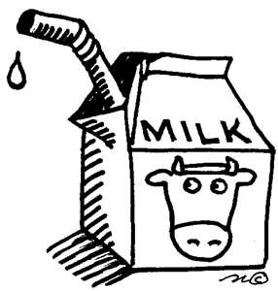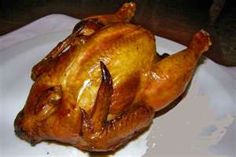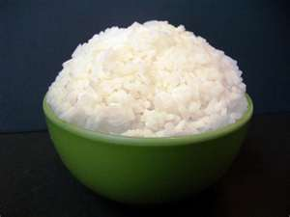

a. b. c. d.
Question 2: Listen and check: 1p
1.
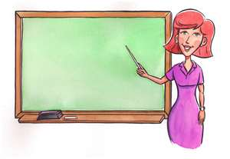
a. b.
2.
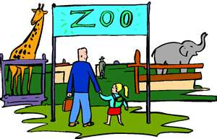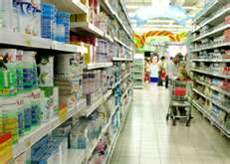
- b.

Question 3. Match a question in column A with an answer in column B: 2ps

A | B | Answers
1. What time do you go to school? | A. They are 40,000 dong. | 1.-
2. Why do you like bears? | B. At 7.30. | 2.-
3. How much are the shorts? | C. It’s red. | 3.-
4. What colour is it? | D. Because they can climb. | 4.-

Question 4: Complete the sentences with the words in the box:2ps

books some because stall

My mother and I want to do some shopping. First, we go to the clothing store (1) ______________ my mother wants to buy a blouse. Then, we go to the bookshop because I want some (2)_____________. Finally, we go to the food (3)_______________ because we want to buy (4) __________ food.

Question 5: Reorder the words to make sentences: 2ps
1. school / I / at / go / to / o’clock / seven /.

2. is / What / it / time /?

3. is / What / it / colour/?

4. much / are / shoes / How / these /?

Question 6:Fill in the blanks. 2ps
- I ______________________ at 7 o’clock. 
- He ________________________at 7 o’clock.____ 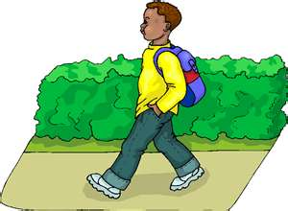
- I have a green _________________.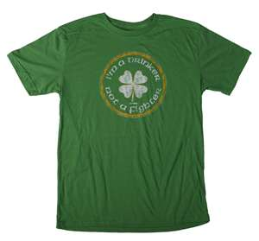

- ________________ can jump. 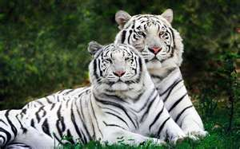

_The End_gfg
Transcrips for question 1:
1. I’m hungry. I’d like some rice.
2. A: I like chicken. What about you?
- B: I like chicken too. It’s my favourite food.
3. I like milk. It’s my favourite drink.
4. Hamburger is my favourite food.

Transcrips for question 2:

- This is my mother. She is a teacher.
- A: I want to buy some clothes.
B: Let’s go to the supermarket.

Trung Nguyen Primary School.
Full name:……………………………
Class:…………………………………
THE SECOND TERM TEST
School Year : 2012 - 2013
Time: 40 minutes
I. Circle the words you hear.
1. A. zoo B. too 3. A. can B. dance
2. A. time B. climb 4. A. near B. here
5. A. blouse B. house
II. Listen and tick.
- ___a. I like blue shirts. 4. ___a. My father likes brown ones.
___b. I like red shirts. ___b. My father likes black ones.
2. ___a. We all like white shirts. 5. ___a. My brother likes black shoes.
___b. We all like yellow shirts. ___b. My brother likes blue shoes.
3. ___a. My sister likes red ones.
___b. My sister likes white ones.

III. Complete the sentences.
dr | i | mon | st | bl
- I like t_gers.
- Alan likes _ _ _keys.
- Let’s go to the po_ _ office.
- How much is the black _ _ess?
- She likes that _ _ue blouse.

IV. Write the sentences under the pictures.

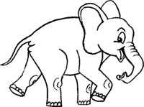

1. I like…………………………. 2. Let’s go to…………………..
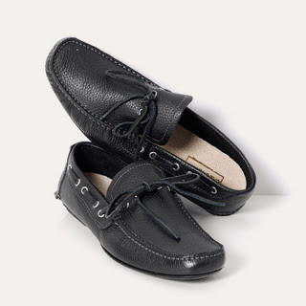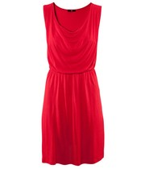

3. They like…………………………. 4. She likes…………………

V. Choose the best answer.
1. Why do you like bears?
A. Because they can sing.
B. Because they can read.
C. Because they can climb.
2. Why do you go to the food stall?
A. Because I want some books.
B. Because I want some hamburgers.
C Because I want some stamps.
3. What colour is it?
A. It’s hot.
B. It’s big.
C. It’s blue.
4. What colour are they?
A. They’re small.
B. They’re red.
C. They’re nice.
5. How much are they?
A. They’re nice.
B. They’re beautiful.
C. They’re twenty-five thousand dong.

The end !
***********************

