Full name: ……………………………. School:……………………………
I. DEFEAT THE GOAL KEEPER
1. Choose the word that has the underlined part pronounced differently
A. bus B. but C. put D. cut
2. Let's learn some __________
A. much B. many C more D. most
3. I ________ have a motorbike.
A. don't B. doesn't C. am not D. not
4. Choose the word that has the underlined part pronounced differently
A. do B. mother C. brother D. sometimes
5. Nam is happy __________ today is his birthday.
A. so B. but C. and D. because
6. Do you like music? - ___________________
A. Yes, I am B. Yes, I do C. Yes, I don't D. No, I'm not
7. Are your pens in your bag?
A. Yes. It is B. Yes. They are C. No. It isn't D. Yes. It is not
8. I like music because I like ________
A. swimming B. playing C. singing D. going
9. Choose the word that has the underlined part pronounced differently
A. bag B. bank C. parents D. place
10. How's the weather _______Hanoi?
A. on B. at C. for D. in
11. Choose the word that has the underlined part pronounced differently
A. five B. sister C. fine D. nine
12. Mary ______to the music now.
A. listens B. listen C. is listening D. listening
13. Stand _____, please!
A. on B. in C. up D. of
14. There are _________clouds.
A. look B. small C. cloudy D. watch
15. Would you like ________biscuits?
A. some B. an C. a D. Ø
16. She ______ a long hair.
A. have B. does C. has D. do
17. There are ______students in my class. Twenty boys and twenty girls.
A. forty B. fifty C. twenty D. thirty
18. Her mother works as a _________ at Hue hospital.
A. singer B. farmer C. nurse D. postman
19. How many _________ are there?_ Two. Mary and Jane.
A. girl B. boy C. boys D. girls
20. Is this your school bag? _ Yes, it is. It's ________.
A. my B. me C. mine D. I
II. FILL THE BLANK
1. N__SE 21. E__AM
2. STO__Y 22. MU__EUM
3. DA__CE 23. __ITHER
4. PE__CH 24. C__IMB
5. H__AD 25. J__LY
6. T__IN 26. K__TCHEN
7. DO__N 27. SK__RT
8. NUM__ER 28. W__FE
9. PL__ASE 29. SOC__
10. TRO__SERS 30. CA__DY
11. M__Y 31. PI__ZA
12. BED__OOM 32. AL__AYS
13. E__SY 33. VIL__AGE
14. NUM__ER 34. SUM__ARY
15. COL___UR 35. TA__LE
16. THI__D 36. P__OR
17. D__AR 37. AB__UT
18. CI__EMA 38. NU__SE
19. FU__NY 39. RI__H
20. __HREE 40. BO__RD
41._ _ _ _ _ is he from? - He's from England.
42. Living in Ho Chi Minh City _ _ so boring.
43. Bill is 20 and is a doctor. He _ _ _ _ _ in a hospital.
44. He gets a lot of gifts _ _ Christmas.
45. Vegetables and fruits are good _ _ _ us.
46. Lida lives _ _ London.
47. Mrs. Jenney is my teacher. She _ _ _ _ _ _ _ me History.
48. He's always busy _ _ _ _ _ _ _ he's a businessman.
49. The library opens _ _ 7 a.m
50. What meat would you like _ _ _ dinner, Jane?
51. In the evening, I am always busy _ _ _ _ my homework.
52. What did your little sister do yesterday? - She v _ _ _ _ _ _ in the museum.
53. What's _ _ _ dinner today? Bread or rice?
54. We have English on Monday and Sunday. We have it _ _ _ _ _ a week.
55. There is a picture _ _ Uncle Ho on the wall.

Full name: ……………………………. School:……………………………
BÀI TẬP 1: DEFEAT THE GOALKEEPER
1. How much are your shoes? - _____________________
A. They are nice B. It's 70, 000 dong C. They are 70,000 dong D. They are black
2. How ______books does he have?
A. are B. much C. many D. more
3. I have two brothers. ________names are Minh and Tung.
A. His B. They C. Theirs D. Their
4. He is going to the _________ to post a letter.
A. post office B. market C. bookshop D. cinema
5. Let's _______ to the zoo and see the animals.
A. goes B. to go C. go D. going
6. How's the ________ in Hanoi? _ It's cold and windy.
A. people B. trees C. life D. weather
7. How about _________ to the supermarket?
A. going B. go C. to go D. went
8. Hurry ______! We'll late for school.
A. in B. of C. up D. down
9. You can see lions in the _________.
A. park B. post office C. police station D. zoo
10. Can you play the guitar? - _____________
A. Yes, I can't B. Yes, I can C. No, I can D. Yes, I am
11. We shouldn't ...... a lot in the evening
A. eat B. to eat C. eats D.eating
12. What's the matter, Danny? - I'm ......
A. nice B.cold C. big D. tall

13. The boy ..... his teacher some beautiful flowers.
A. like to give B. like giving C. likes gives D. would like to give
14. ........ about going to Nha Trang?
A. Why B.What C.Where D. When
15. We have lots of ...... in the summer.
A. rain B. raining C. rains D. rainy
16. There are twelve months in a ......
A. week B. year C. weekend D. daily
17. They buy some fruit but ........ vegetables.
A. some B. any C. little D.no
18. ......... walk on the grass!
A. No B.Not C. Don't D. Doesn't
19. Choose the word that has the underlined part pronounced differently
A. camp B. table C. travel D. match
20. Odd one out
A. dog B. cow C. pig D. string

BÀI TẬP 2: FILL THE BLANK

1. I want _ _ have a pen friend from England.
2. Please write _ _ me!
3. _ _ _ _ _ do you often go in your free time?
4. Which _ _ _ _ _ _ _ _ do you have today? - I have English and Maths.
5. In the _ _ _ _ _ _ _ _ _ _ _ lessons, we learn how to use the computer.
6. Candies are not good _ _ _ children's teeth.
7. How _ _ _ _ _ listening to music?
8. Would you like a cup _ _ coffee? - Yes, please.
9. Where _ _ _ _ you yesterday? - I was at home.
10. _ _ _ _ _ are three books on the table.
11.C_ECK → 20. SIC_NESS → 29. MU_EUM→
12.S_IENCE → 21. GLA_S→ 30. AC_IVITY→
13.LAN_UAGE → 22. AL_AYS →
14.S_ISSORS → 23.CAPI_AL →
15.T_OTH → 24.FU_NY →
16.AI_PORT → 25.LE_TER →
17.CONN_CT → 26.MAT_H →
18.CIRC_E → 27. S_ADIUM →
19.AMUSE _ENT → 28. SI_N →
BÀI TẬP VÒNG 21 (tiếp)

Full name: ……………………………. School:……………………………

I. Cool Pair Matching: Match a picture or a Vietnamese word with its English equivalence.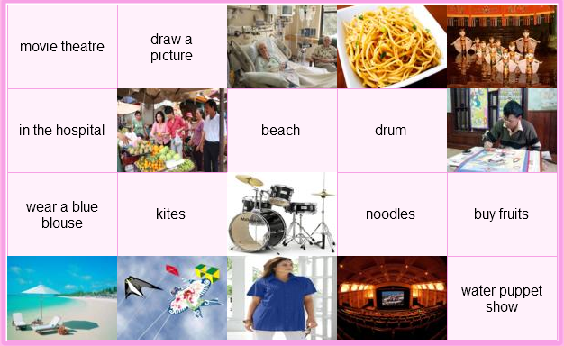

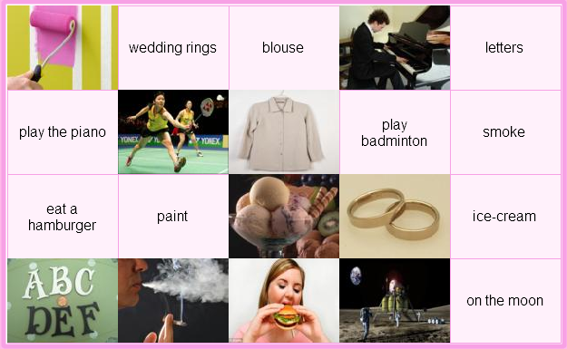

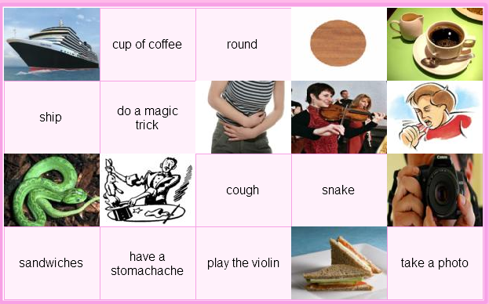

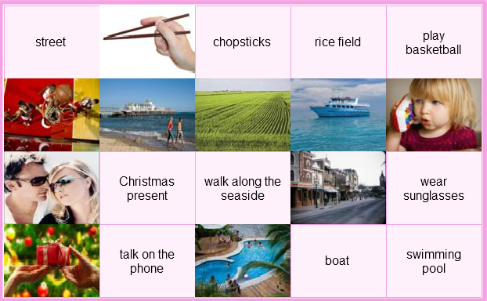

Full name: ……………………………. School:……………………………
II/ Safe Driving
Answer the question.
1. I am tired because I have to _ _ the housework all day.
2. George eats too much so he's getting _ _ _ .
3. What _ _ _ _ do you get up? - I get up at 7 a.m.
4. Let's play hide-_ _ _ -seek.
5. We danced, sang and t_ _ _ stories in English.
6. His job is great because he can meet a _ _ _ of people.
7. We had celebrations _ _ the schoolyard.
8. They are rich _ _ they don't have to work.
9. Kate and I are reading books _ _ _ _ _ pets.
10. Are the students _ _ _ _ _ _ _ _ _ to music? No, they're playing volleyball.
11. What's his job?- He's a .......
A. teacher B. engineer C. work D. house work
12. Do you like to ......?
A. hear to music B. listen music C.listen to music D. listen of music
13. Choose the word that has the underlined part pronounced differently
A. bottle B. job C. movie D. chocolate
14. Fish is my favourite ....
A. drink B. food C. fruit D. juice
15. My son often ....... his teeth before going to bed.
A. washes B. brushes C. clean D. gets
16. Choose the word that has the underlined part pronounced differently
A. some B. come C. love D. home
17. Choose the odd one
A. fifteen B. twenty C. one hundred D. time
18. ........ go to the movies tonight? - OK.
A.Let's B. What about C. Why don't we D. How about
19. What are we going to do? - ......
A. Let we go camping B. Why do we go camping?
C. What about going camping? D. What about to go camping?
20. ....... Music lessons, we learn to sing songs
A. On B. Between C. At D. During
21. People often go to the ....... to swim,
A. Stadium B. beach C. mountain D. city
22. My family are going to stay at a ..... house in Nha Trang.
A. friend B. friends C. friend's D. friends'
23. ....... your mother like noodles? - No, she wouldn't.
A. Can B. Would C. Can't D. Does
24. There are ...... hundred students in our school.
A. three B. third C. threeth D. thirth
25. How is your little daughter? - She is fine ........
A. thank B. thank you C. thanks you D. you thank
26. How often does your aunt go to the farm? -
A.One B. Once a week C. Two D. Once time
27. What is your ...... season? - Summer.
A.likes B. interesting C. favourite D. good
28. Xiao Mei is Chinese. She ....... Chinese.
A. says B. talks C. speaks D. tells
29. I don't like living in Sapa because it ........
A. always rain B. always to rain C. rain always D. always rain
30. I'm travelling by bus and ..... a lot of interesting places.
A. visit B. to visit C. visiting D. is visiting
31. My father is an engineer. - My sister is an engineer, ....
A. too B. either C. to D. so
32. The ......... is cold and wet.
A. time B. day C. weather D. season
33. The Bakers are going to visit ...... of interesting places.
A. a much B. a many C. a lot D. a little
34. Choose the word that has the underlined part pronounced differently.
A. all B. always C. ball D. watch
35. What's ....... breakfast, mom? - There's some bread and eggs.
A. on B. of C. for D. in
36. How many ...... are there in a year? Four.
A. months B. days C. seasons D. weeks
37. Choose the odd one
A. carrot B. rice C. noodle D. bread
38. My sister doesn't have ......
A. hair long black B. long black hair C. black long hair D. black hair long
39. I want to go to the ...... to see some tigers.
A. post office B. bookshop C. clothing store D. zoo
40. Mr and.Mrs Pike..... dinner at the moment.
A. is having B. are having C. are eating D. B & C are correct

Full name: ……………………………. School:……………………………

I/ Cool Pair Matching
Match a picture or a Vietnamese word with its English equivalence.

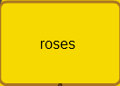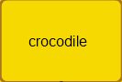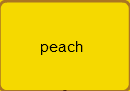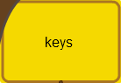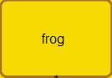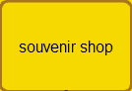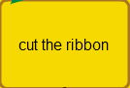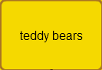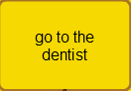

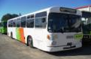

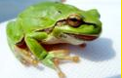

II/ Safe Driving
Answer the question.
1. ....... you understand all of the new words? - Yes, I do.
A.Is B.Are C.Do D.Does
2. My father works ........ an engineer for his factory.
A.for B.at C.as D.of

3. My class is ...... 7a.m ....... 11 a.m everyday.
A.between/from B.from/in C.from/to D.at/at

4. There are a lot of interesting ...... in the festival.
A.game B.activities C.action D.baseball

5. ...... is your aunt's address? - It's on the table.
A.Where B.How C.When D.Which

6. Mike is playing soccer with his friends. "Soccer" means
A.tennis B.table tennis C.fooball D.badminton

7. Why does your mother go to the food stall? - Because she wants some ........
A.books B.stamps C.hamburgers D.T-shirts

8. Are you free ...... Friday evening?
A.in B.at C.on D.from

9. She is learning ...... to use a computer.
A.what B.when C.where D.how

10.Yesterday they ......... to Ha Long Bay.
A.went B.go C.are going D.to go
***********************
Full name: ……………………………. School:……………………………

I/ LEAVE ME OUT!
BÀI TẬP 1
1. HELSP 6. REAOD
2. LISTTEN 7. NIEGHT
3. THROEW 8. SCIENSCE
4. FLOWEAR 9. SKIRET
5. WRITSE 10. WARAM
BÀI TẬP 2
1. OSTHER 6. GROSUP
2. TELEOVISION 7. PRINST
3. BRIANG 8. SEVEAN
4. SPRIENG 9. LIGHET
5. LIBARARY 10. HEASRT
BÀI TẬP 3
1. NATLION 6. MISES
2. PICKTURE 7. REPEAST
3. BORIN 8. YOFUNG
4. PHELP 9. REALDY
5. IDEAP 10. PLACKE
BÀI TẬP 4
1. HAPPYEN 6. MIAME
2. BLEACK 7. STREEST
3. SEPTEMBEAR 8. THEAME
4. DRAWN 9. CLEASS
5. TOBY 10. VISICT
II/ HELP BEAR FIND THE HONEY
1. We have English ________ Friday.
2. ______old are you? - I'm seven years old.
3. Thank you ______ much
4. W_______is Mary from?
5. _______color is it? - It's red
6. ______are you? - I'm fine. Thanks.
7. There are four people ______ my family.
8. ________time do you go to bed?
9. There _____ one living room and one kitchen in my house.
10. Why do you want to _____to the bookshop?
11. My brother is a factory _______. He works in a factory.
12. We like going to the zoo _____much.
13. After dinner, my mother checks my homework b_______bedtime.
14. My sister takes vegetables _____ the market.
15. Sometimes, I go out ______ my friends.
16. I'd like _______orange, please.
17. My father w_______hard everyday.
18. They are farmers. They work o_ a farm.
19. The museum _____behind the park.
20. Let's go out _________a walk.
21. Alan wants to be a taxi d___________.
22. I like _____play the piano, too.
23. Tom ___________born on October 24th.
24. There are _________people in my family: my parents, my brother and me.
25. What __________ your father do? - He is a farmer.
26. My brother is ____ engineer.
27. Nga is a student in class 5A, Quynh Mai P_____________ school.
28. I want to be a singer b__________I like to sing.
29. The cinema is between the park _______the post office.
30. I don't know how _______DANCE.
***********************
Full name: ……………………………. School:……………………………

BÀI TẬP 1: HELP BEAR FIND THE HONEY
1. Choose the odd one:
A. write B. sing C. read D. friend
2. Choose the word that has the underlined part pronouced differently
A. pen B. desk C. children D. spell
3. Can she play the piano?
A. Yes, I can B. Yes, he can C. Yes, she can D. Yes, we can.
4. _____you understand all of the new words?- Yes, I do.
A. Do B. Are C. Does D. Is
5. How many rooms are there in your _______
A. classroom B. roomates C. apartment D. meeting-room
6. _______is your aunt's address? - It's on the table.
A. Where B. How C. When D. Which
7. Do their parents live ____Hue City?
A. in B. at C. on D. from
8. Choose the odd one:
A. breakfast B. eat C. dinner D. lunch
9. Now, look ____your book. Who can answer the third question?
A. up B. for C. in D. at
10. I'm going to the ________to borrow some book.
A. bookshop B. café C. library D. shelf
BÀI TẬP 2: LEAVE ME OUT!
1. CHEASS 11. WATEER
2. TELERPHONE 12. MABLE
3. BIANGO 13. IDEAR
4. DOWIN 14. BUSTY
5. FINEISH 15. ENODUGH
6. FIVELD 16. PLANKE
7. NEPAR 17. LESMON
8. EXCIATING 18. SABD
9. PICANIC 19. CANODLE
10. CELEYBRATE 20. BORAT

VÒNG 25 (CẤPTỈNH)_LỚP 5

I/ Safe Driving
Answer the question.

1. What's his job?- He's a .......
A. teacher B. engineer C. work D. house work

2. Do you like to ......?
A. hear to music B. listenmusic C.listen to music D. listen of music

3. Choose the word that has the underlined part pronounced differently
A. bottle B. job C. movie D. chocolate

4. Fish is my favourite ....
A. drink B. food C. fruit D. juice

5. My son often ....... his teeth before going to bed/
A. washes B. brushes C. clean D. gets

6. Choose the word that has the underlined part pronounced differently
A. some B. come C. love D. home

7. Choose the odd one
A. fifteen B. twenty C. one hundred D. time

8. ........ go to the movies tonight? - OK.
A.Let's B. What about C. Why don't we D. How about

9. What are we going to do? - ......
A. Let we go camping B. Why do we go camping?
C. What about going camping? D. What about to go camping?

10. ....... Music lessons, we learn to sing songs
A. On B. Between C. At D. During

11. People often go to the ....... to swim,
A. Stadium B. beach C. mountain D. city

12. My family are going to stay at a ..... house in Nha Trang.
A. friend B. friends C. friend's D. friends'

13. ....... your mother like noodles? - No, she wouldn't.
A. Can B. Would C. Can't D. Does

14. There are ...... hundred students in our school.
A. three B. third C. threeth D. thirth
15. How is your little daughter? - She is fine ........
A. thank B. thank you C. thanks you D. you thank

16. How often does your aunt go to the farm? -
A.One B. Once a week C. Two D. Once time
17. What is your ...... season? - Summer.
A.likes B. interesting C. favourite D. good

18. Xiao Mei is Chinese. She ....... Chinese.
A. says B. talks C. speaks D. tells

19. I don't like living in Sapa because it ........
A. always rain B. always to rain C. rain always D. always rain

20. I'm travelling by bus and ..... a lot of interesting places.
A. visit B. to visit C. visiting D. is visiting

21. My father is an engineer. - My sister is an engineer, ....
A. too B. either C. to D. so

22. The ......... is cold and wet.
A. time B. day C. weather D. season

22. The Bakers are going to visit ...... of interesting places.
A. a much B. a many C. a lot D. a little

23. Choose the word that has the underlined part pronounced differently
A. all B. always C. ball D. watch

24. What's ....... breakfast, mom? - There'ssome bread and eggs.
A. on B. of C. for D. in

25. How many ...... are there in a year? Four.
A. months B. days C. seasons D. weeks

26. Choose the odd one
A. carrot B. rice C. noodle D. bread

27. My sister doesn't have ......
A. hair long black B. long black hair C. black long hair D. black hair long

28. I want to go to the ...... to see some tigers.
A. post office B. bookshop C. clothing store D. zoo
II/ Fill in the blank
1. _ _ _ _ does he do? - He's a police officer.
2. How _ _ _ _ is a pair of shorts? - It is 90.000 dong.
3. I'm going to the post _ _ _ _ _ _ . I want to buy some stamps.
4. December is the twelfth _ _ _ _ _ of the year.
5. _ _ _ do you like Informatics? - Because it is interesting.
6. _ _ _ is Ann's English teacher? - Mrs. Susan.
7. Why are Science lessons interesting _ _ _ her?
8. How _ _ _ _ super markets are there in your city?
9. My uncle _ _ _ _ _ as a doctor in the hospital.
10. My daughter wants to become a teacher _ _ English.
11. I have a headache. - You should _ _ _ _ some aspirins.
12. What is his _ _ _ ? - He designs houses.
13. He plays soccer _ _ _ _ his friends in his free time.
14. _ _ _ much homework did you have yesterday?
15. My children like bears _ _ _ _ _ _ _ they can jump and climb.
16. When I _ _ _ a little girl, I liked candies very much.
17. What'sthe weather _ _ _ _ in winter in England?
18. On _ _ _ _ occasion do you wear your favourite clothes?
19. It is very cold in winter. There is _ _ sun. There is only snow.
20. is your sister eight years _ _ _ ?
21. What's the matter _ _ _ _ you?

III/ Cool Pair Matching
Match a picture or a Vietnamese word with its English equivalence.

