SỞ GIÁO DỤC VÀ ĐÀO TẠO …………….  PHÒNG GD&ĐT ……………  HỌ TÊN: …………………………..  Lớp: ………………………………….. | ĐỀ KIỂM TRA HỌC KỲ I  MÔN TIẾNG ANH- LỚP 4  NĂM HỌC 2015-2016  Thời gian: 40 phút (Tờ 1)
Marks | Listening |  |  |  |  | Reading and writing |  |  |  | Speaking | Total
Marks | Q.1 | Q.2 | Q.3 | Q.4 | Q.5 | Q.6 | Q.7 | Q.8 | Q.9 | Q.10


PART I. LISTENING ( 20’)
Question1: Listen and number.(2pt).


A. ◻ B. ◻



C.◻ D.◻

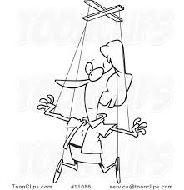
Question2: Listen and color. (2pt)


1 . 2. 3. 4.
Question3: Listen and draw the line ( 2pt):
PHONG MAI







QUÂN NAM HOA

Question4. Listen and tick (2pt) Example
✓



1.Where’s your school ? It’ in ………………..
A.◻ B. ◻ C.◻



2. When’s your birthday ? It’s on the ………………………
A. ◻ B.◻ C. ◻


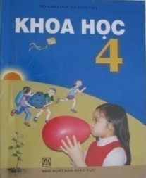

3.What subjects do you have today ? I have ………………………..
A. ◻ B.◻ C.◻




4. What do you like doing ? I like …………….
A.◻ B. ◻ C. ◻
Question5: Listen and write the words. (2pt)
Example: 0. A: What is your name?
B: My name is Tony.
- A: what subjects do you have today ?
B: I have ………………………..
- A: what did you do yesterday ?
B: I ………………...a picture
- A: where’s your school ?
B: It’s in Hoan Kiem ……..
- A: what can you do ?
B: I can play ………………………
SỞ GIÁO DỤC VÀ ĐÀO TẠO LONG AN  PHÒNG GD&ĐT ĐỨC HÒA  HỌ TÊN: …………………………..  Lớp: ………………………………….. | ĐỀ KIỂM TRA HỌC KỲ I  MÔN TIẾNG ANH- LỚP 4  NĂM HỌC 2015-2016  Thời gian: 40 phút (Tờ 2)

PART II. READING (20’)

Question6: Look and read. Put a tick or cross in the box as example. (5pt)
  - She is Malaysian. . | 6.He was on the beach .
- It’s the twenty  second  of December. | 7. I’m in class four C
  - 3. She can’t ride a bike. | 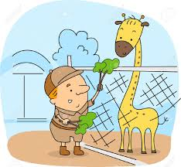  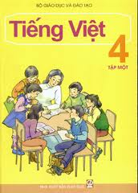    8. I have Science .  
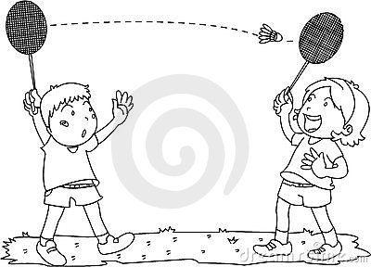  4.They are playing  football . |   9. He watered the puppet.
  - Good evening . | 10. she is writing a dictation.
Question7: Read and write the suitable words in the gaps . (5pt)
Hello , My name’s Alex. I comefrom England .Now I’m living and studying in Ha Noi . My favourite lessonsare Vietnamese and Art . I have many classmates and they have different favourite classes. Linda wants to learn about the world around ,so she likes Science . Quan is good at calculating because He likes Maths . Mai prefer Music . Lucy likes IT. And my best friend Phong loves P.E
- Linda likes _________ .
- Quan likes__________
- Mai’s favourite subject is _____________because she wants to be a singer .
- Lucy is good at ___________because she like playing computer games .
- Phong likes __________because he wants to be an Athlete .

PART II. READING (20’)

Question8: Look at the pictures. Look at the letters. Write the words (5pt):




1. napaj -------------------------- 6. matps---------------


2. cagindn------------------------- 7. debooyg-------------------
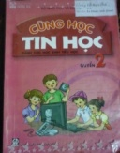

3. tionrofnima gychetnolo
----------------------------------- 8. lusariata-----------------


4. ttsree-------------------------- 9. napoi------------



5.kasm -------------------------- 10. catigwnh-------------

Question9:Fill in each gapwith a suitable word from the box (5pt):
Girl music can speak swim Maths

Hi , Jim !
How are you ? How are your new teachers and classmates? We miss you so much . By the way , there are three newcomers in our class . Linh is a little lovely (0) girl . She is very talented . She (1 ) _________ draw beautiful pictures . Tom is very sporty. He can (2)_________very fast. He is also intelligent . He always gets good marks at (3)______. The last one is Sue. She loves (4)__________and she can play the pianon. There is a good news . I can (5) _________ English better now . Write to me when you get free time . Ok ?

