SỞ GIÁO DỤC VÀ ĐÀO TẠO HÀ NỘI

Sáng kiến kinh nghiệm

Phát huy hiệu quả hoạt động cặp, nhóm trong quá trình dạy học tiếng Anh ở trường THPT

Người viết: Nguyễn Thị Việt Hoa
Tổ : Xã Hội
Trường : THPT Ngọc Hồi
Năm học: 2009 - 2010
CONTENTS

A. REASONS FOR CHOOSING THE RESEARCH
B. AIMS OF THE RESEARCH
C. SCOPE, OBJECT AND RESEARCHING METHOD
D. MAIN CONTENT
I. GENERAL INTRODUCTION
1. What are pair work and group work?
2. Main advantages, problems and solutions to the problems.
II. ORGANIZING PAIR WORK AND GROUP WORK
1. Group and pair work organization.
2. Demonstration.
3. Suggestions for some popular kinds of practice.
E. RESULT AFTER APPLYING THE RESEARCH IN TEACHING
F. CONCLUSION
G. REFERENCE BOOKS

A. REASONS FOR CHOOSING THE RESEARCH
- Pair work and group work are the main activities in teaching English at schools.
- Teachers at high schools are in the period of getting used to new English textbook. Pair work and group work didn’t use to be organized in class, so a lot of us – teachers of English at high school – get stuck in organizing pair work and group work effectively.
- Some teachers haven’t been clearly aware of the roles of pair work and group work in teaching and learning a foreign language.

B. AIMS OF THE RESEARCH
- To introduce pair work and group work and to show the advantages of working in pairs and groups.
- To show how to organize pair and group work effectively and how to deal with initial problems that may arise.
- To show how pair and group work can be used for various classroom activities.
- To give teachers confidence in using pair and group work themselves.

C. SCOPE, OBJECT AND RESEARCHING METHOD
- Scope : Researching in the process of teaching English at Ngoc Hoi high school.
- Object: This subject is concerned with ways of organizing activities in the class.
- Researching method: Reading reference books , discussing with other teachers, applying in teaching, observing and drawing out experiences.

D. CONTENT
I. GENERAL INTRODUCTION
1. What are pair work and group work?
1.1. Pair work:
The teacher devices the whole class into pairs. Every student works with his or her parner and all the pairs work at the same time. The teacher walks around, listens and intervenes little if necessary.
1.2 Group work :
Students work in small groups (of four or five) on tasks that entail interaction: conveying information, for example, or group decision making. All the groups work at the same time. The teacher walks around listening, intervenes little if at all
2. Main advantages, problems and solution to the problems.
For certain types of activity, pairwork and groupwork have number of advantages over working with the whole class together. Teachers should think what the main advantages are, and also what problems might be involved in pairwork, groupwork and the solutions for these.
Here are some main advantages and problems:

Advantages | Problems
More language practice  Students are more involved  Students feel secure, confident  Students help one another  Save time | Noise  Students make mistakes  Difficult to control  …………………..

( Of course, your own advantages and problems may look slightly different from these, but most teachers suggestions will probably fit under these headings)
Now, we will discuss each heading in more detail. First, let’s start with the advantages

*More language practice:
Pairwork and groupwork give students far more chance to speak English. For example, students are given an exercise of making sentences (question & answer), working in pair, each student makes as many sentences as they can. If the exercise were done ‘round the class’, students would only say one sentence each , and in a large class many students would say nothing at all.

* Student are more involved:
Some activities will probably be dominated by a few students and others would lose interest if they are conducted with the whole class together. Working in pairs or groups encourages students to be more involved and to concentrate on the task.

* Students feel secure:
Students feel less anxiety when they are working privately than when they are on show in front of the whole class. Pairwork and groupwork can help shy students who would never say anything in a whole class activity.

*Students help each other:
Pairwork and groupwork encourage students to share ideas and knowledge. In a reading actictivity, students can help each other to explore the meaning of a text; in a discussion activity, students can give each other new ideas.

Now talk about the problems, and discuss the ways of recovering them:

* Noise:
Obviously pairwork and groupwork in a large class will be noisy, and this can not be helped. But:
- Usually the students themselves are not disturbed by the noise; it is more noticeable to the teacher standing at the side or to someone in the next room .
- The noise created by pairwork and groupwork is usually “good” noise. Students use English or engage in a learning task. Teacher should stop the activity when most groups or pairs have finished or prepare a “reserve” task to occupy members of groups who finish earlier than expected.

* Students make mistakes:
During a pair or group activity, the teacher can not control all the language used, and should not try to do so. When doing cotrolled language practice in pairs or groups, the number of mistakes can be reduced by:
- Giving enough preparation, the activity can be done with the whole class first, and pair work used for final stage.
- Checking afterwards. The teacher can ask some pairs or groups what they said , and then correct mistakes if necessary.

*Difficult to control class:
The teacher has less control over what students are doing in pairwork and groupwork than in normal class. To stop activities getting out control, it is important to:
- Give clear instructions about when to start, what to do and when to stop.
- Give clearly defined tasks which don’t continue for too long.
- Set up a routine, so that students accept the idea of working in pairs or groups, and know exactly what to do.

II. ORGANIZING PAIR WORK AND GROUP WORK
1. Group and pair work organization
- The success of group or pair work depends on some extents:
The surrounding social climate .
How habituated the class is to using it
The selection of an interesting and stimulating task whose performance is well within the ability of the group or pair.
- More immediately, it also depends on:
Effective and careful organization.

2. Organization steps:
2.1. Presentation:
The instructions that are given at the beginning are crucial. If the students do not understand exactly what they have to do, there will be time-wasting, confusion, lack of effective practice, possible loss of control. Select tasks that are simple enough to describe easily; and in monolingual classes, you may find it cost-effective to explain some or all in the students’mother tongue. It is advisable to give the instructions before giving out materials of dividing the class into groups; and a preliminary rehearsal or ‘dry run’ of a sample of the activity with the full class can help to clarify things. If your students have already done similar activities, you will be able to shorten the process,giving only brief guidelines;It is mainly the first time of doing something with a class that such care needs to be invested in instructing.
Try to foresee what language will be needed, and have a preliminary quick review of appropriate grammar or vocabulary. Finally before giving the sign to start tell the class what the arrangements are for stopping: If there is a time limit, or a set signal for stopping, say what it is; if the groups simply stop when they have finished, then tell them what they will have to do next. It is wise to have a reserve task planned to occupy members of groups who finish earlier than expected.
2.2. Process:
Teacher goes from group to group, pair to pair, monitor, and either contribute or keep out of the way whichever is likely to be more helpful. If you do decide to intervene, your contribution may take the form of :
- Providing general approval and support;
- Helping students who are having difficultly;
- Keeping the students using the target language(in many cases your mere presence will ensure this!)
- Tactfully regulating participation in a discussion where you find some students are over dominant and others silent.
2.3. Ending:
Draw the activity to a close at a certain point. Try to finish the activity while the students are still enjoying it and interested, or only just beginning to flag.
2.4. Feedback:
A feedback session usually takes place in the context of full-class interaction after the end of the group work. Feedback on the tasks may take many forms:
- Giving the right solution, if there is one.
- Listening to and evaluating suggestions.
- Pooling ideas on the board.
- Displaying the meterials the groups/ pairs have produced.
And so on.
The main objective here is to express appreciation of the effort that has been invested and its results. Feedback on language may be integrated into this discussion of the task, or provide the focus of a separate class session later.

3. Demonstration:
3.1. Example of pair work:
Example 1:
A teacher has an intermediate class. She presented “like/don’t like” and then she uses this exercise for free practice in pairs:
Exercise 3: Likes and dislikes
Pairwork : Ask what your friend likes and doesn’like
Ask about:
Food Clothes Sport School subjects
- Things the teacher did before , during and after the activity.
Before: Teacher says “All right. Exercise 3. Work in pairs; ask and answer the questions”
During: Teacher sit at one place and says nothing.
After: Teacher says “ Everyone finished? Good. Now look at exercise 4 …….”
- Some question for us:
Do you think the activity was successful?
What do you think might have gone wrong?
What could she do to make it more successful?
*Discuss why the activity was not successful , and what the teacher could do to make it more successful:
- She could prepape for the pairwork by establishing what the questions and answers should be. She could also demonstrate the pairwork by asking questions round the class, or by getting one pair of students to ask and answer in front of the class. Then students would know exactly what to do.
- She could be more active in starting the pairwork. Instead of just saying ‘work in pairs’, she could show students who to work with, check that everyone had started working in pairs. This would be very important if the class were not used to pairwork.
- During the activity, she could move quickly round the class to check that students were talking and to see when they finished.
- Instead of waiting for everyone finished , she could stop the activity. Then there would be no chance for students to get bored and start talking about other things.
- After the pairwork, she could ask some pairs what they said, or ask a few pairs to repeat their conversation in front of the class.
Example 2:
Teacher presented “used to /didn’t use to + inf (Unit 4, part E – language focus) and then used the following exercise for free practice in pairs.
Exercise: Work in pairs, ask what your friends used to do and didn’t use to do (Ask about food, sport, music, school, subject ……. ).
A possible procedure:
* Introduce the exercises and show what questions and answers students can give:
Teacher: Now you are going to talk about things you used to do and things you didn’t use to do. Look at the exercise. What question can you ask?
What about food?
Student A: What food did you use to eat when you were small?
Student B: I used to eat ice – cream.
(And so on)
*Write the basic question on the board:
What (food) did you use to eat?
*Ask a few questions round the class to show the kind of conversation students might have:
Teacher: What kind of music did you use to listen, Huong?
Student: I used to listen to pop music.
Teacher: Pop music? when did you use to listen to it?
( And so on)
If teacher likes, ask two students to have similar conversations, while the others listen.
* Divide the class into pairs:
Teacher: Now. You’re going to work in pairs (Indicate by pointing. If there are single students left without a partner, make groups of three). Ready? Ask and answer the questions. First, one person asks all the questions then change round. Start now.
* Students work in pair. Teacher moves quickly round the class, checking that everyone is talking (but do not try to correct mistakes, as this will interrupt the activity)
* When most pairs have finished, stop the activity. Ask a few students what their partners said:
Teacher : Now, stop talking. Mai, tell me about Huong. What did she used to do?
Student : She says she used to eat ice cream, listen to pop music and swim in the afternoon , she liked meat but she didn’t use to eat it. She was afraid of being overweight
* Give feedback
- Well done.
- Pay attention to….
(And so on)
3.2. Example of group work.
Task 4 (Unit 5 – Part B: Speaking - English 10)
This is a free activity and aims to develop fluency in speaking. The procedure may be:
Divide students into groups of four or five.
Read through the instrutions and make sure that each group understands what to do. Choose one “secretary” in each group to write the list but emphasis that everyone in the groups should agree on what to write.
While the activity is going on, move from groups, but do not interrupt more than is necessary.
When some groups have finished their discussion, stop the activity, ask one person from each group to report on what they decided
Give feedback: - Content
- Popular mistakes
3.3. Example of dividing the class:
First, draw a plan of your own class of 50 students. Show how you would divide the class for a pair work or a group work activity and what instructions you would give :
Here are two rows of a class of 50 students. The desks are fixed and the students sit on chairs.

1 | 2 | 3

4 | 5 | 6

7 | 8 | 9

10 | 11 | 12 | 13

For pair work: Most students could work with the person next to them. Student 6 could turn round and work with student 3 and students 7, 8, and 9 work as three together. Or student 3 could move to work with student 4 and the second row could be divided into two pairs and one three.
For group work: Students could work in threes and fours along each row. This would be easy to organize but would make it difficult for students to work well as a group, as they would be in a straight line. Or Students in the first row could turn round and form groups with those behind.
The first few times that you try pair or group work, you need to give careful instructions and know exactly how you will divide the class. Pair work and group work can become a routine. Once students are used to it and have regular working partners, it can be organized quickly and easily.

4. Suggestions for some popular kinds of practice
Pairwork and groupwork are not “teaching methods”, but ways of organizing the class. They can be used for many different kinds of activity, and are naturally more suitable for some activities than for others. Before deciding what kind of activity will be used teacher should answer the following questions:
- Could you use pairwork or groupwork for part of the activity?
- If so, exactly what would students do in pairs or groups?
- What would you need to do before the pair /group stage?
- Is there anything you would do after it?
- Is there anything you would do after it?
Here are suggestions for some popular kinds of practice:
*Pattern practice:
This can be done in pairs in the same way as practicing structure with “used to” mentioned in part 2 - Demonstration. Any controlled oral practice can be done first with the whole class, and then in pairs.
* Practising short dialogues:
Acting out short dialogues can very easily be done in pairs, with little chance of making mistakes. It can be done first with pairs of students in front of the class and then with all students working in pairs at the same time.
* Reading a text and answering questions:
Students can disscuss questions in pairs or groups and then read the text or they can read the text silently and then ask and answer questions in pairs or groups. This is a good way of involving the whole class in answering questions.
* Short-writing exercises:
Student can sit in groups and decide together what to write. One student acts as “secretary”. This can be difficult to organise but in a large class it has the advantages that students correct each others’mistakes and the teacher only has a few papers to mark at the end.
Pair work can be used for correcting written work (eg: homework)-students sit in pairs and correct what their partner has written.
* Discussions:
With more advanced class, discussions can be conducted in group. It is important to define the discussion clearly and to ask each group to report their conclusions afterwards.
* Grammar exercises:
Student can do grammar exercises orally in pairs; the teacher goes throught the answers afterwards with the who class and students write the exercises for homework. This is more interesting and productive than students doing exercises alone, in silence.

E. APPLYING THE RESEARCH IN TEACHING

UNIT 8: THE STORY OF MY VILLAGE
Lesson 2: Speaking
Teacher: Nguyen Thi Viet Hoa - Class: 10A4

I. Objectives: By the end of the lesson, students will be able to talk about plans and their possible results.
IV. Anticipated problems:
- There are some new words.
- Students usually know one way to raise plans→ Teacher can ask them to use different ways to talk.
III. Teaching aids: Pictures, textbook, tapes, projector.
IV. Procedure:
Teacher’s activities | Students’ activities
* Warm-up: (3 minutes)  Fill in each gap with one missing letter to make meaningful words  1. RO-D  2. BRI-G-  3. SCH- -L  4. FO-TB-LL GR-UND  5. M-DIC-L C-NT-E  - Asks the fastest one to write the answers on board.  - Give the keys.  1. ROAD  2. BRIDGE  3. SCHOOL  4. FOOTBALL GROUND  5. MEDICAL CENTRE  I. Pre-speaking: ( 3 minutes)  - Shows a picture of Ha Xuyen village.  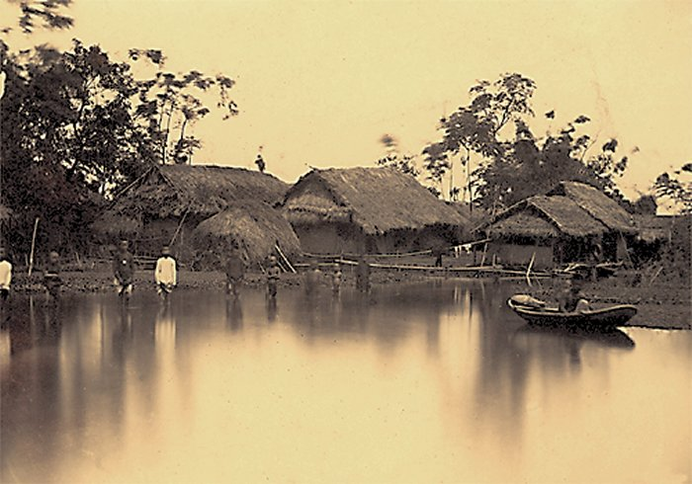  - Asks students to look at the pictures and suggestion to talk about Ha Xuyen village.    Road/ narrow  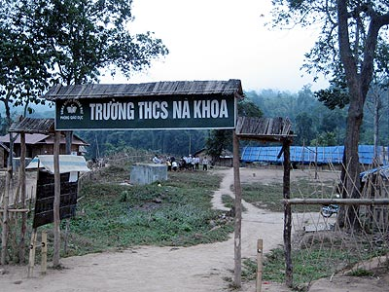  School/ small and poor  + There/ no bridge/ in Ha Xuyen village.  + There/ no medical centre/ in Ha Xuyen village.  + There/ no football ground/ in Ha Xuyen village.  - Raises the question:  What should we do to improve the life in the village?  - Leads in new lesson: Let’s practice talking about the plans to improve the life in Ha Xuyen village and their possible results.  II. While-speaking: (30 minutes)  Task 1: (5 minutes) The villagers of Ha Xuyen are discussing plans to improve the life in the village. Look at the pictures and say what they should do.  - Ask sts to practise in pairs before presenting in front of the class.  Now  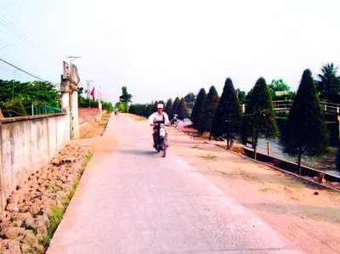  In the future  Now  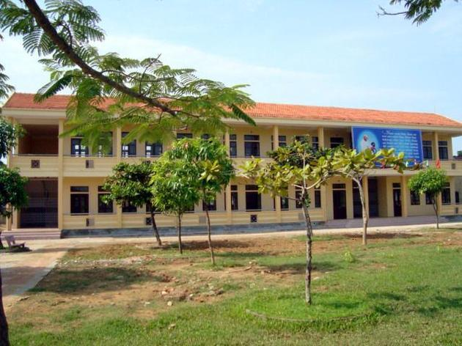  In the future  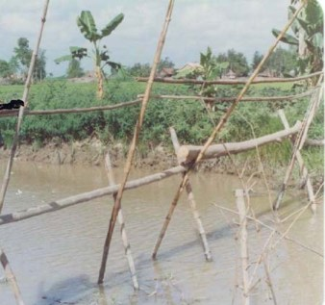  Now  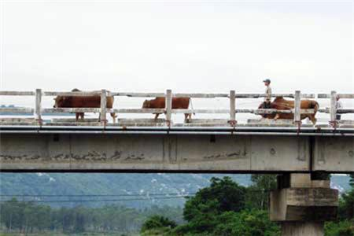  In the future    In the future  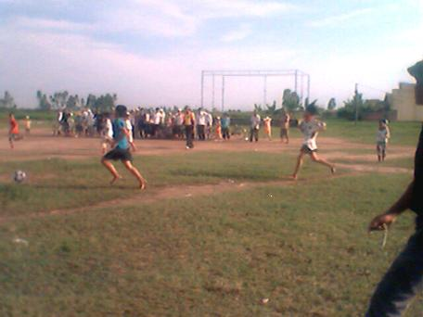  In the future  - Supposes students are Ha Xuyen villagers, give a model:  A: What should we do to improve the life in the  village?  B: I think we should widen the road  - Gives more suggestion and asks students to produce the similar conversations.  + Widen the road  + Build a new school  + Build a bridge  + Build a medical centre  + Build a football ground  Task 2: ( 2 minutes)  Match each of the plans with its possible result  - Raise some plans and possible results:  * Plans:  1. Resurface the road  2. Build a medical centre  3. Build a football ground  4. Grow cash crops  5. Build a bridge  6. Build a new school  * Possible results:  a. Children will have better learning conditions; they will be more interested in learning.  b. Villagers will have a shorter way to town; cars and lorries can get to the village.  c. People’s health will be looked after better; the sick will be cured in time.  d. Young people can play sports; people can hold festival there.  e. People can export the crops; they will have more money.  f. Roads will not be muddy and flooded after it rains; people can get around more easily  - Presents new words.  * Match each word with its Vietnamese equivalent  - Asks one student to write the answers on board  - Give the keys.  * Keys: 1-c; 2-e; 3-d; 4-b; 5-a  - Asks students to match each of the plans with its possible result  - Show the keys and correct the answers on board.  * Keys: 1-f; 2-c; 3-d; 4-e; 5-b; 6-a  Task 3: ( 2 minutes)  Produce conversations in groups of three or four  - Gives model:  A: What should we do to improve the life in the village?  B: I think we should resurface the roads  C: That’s a good idea. If we resurface the roads, they won’t be muddy and flooded.  D: Yes. And people can get around more easily  - Lets students produce conversations in groups.  - Asks some groups to present in front of the class.  IV. Post-speaking: ( 7 minutes)  - Gives question relate to the fact  What should we do to improve our English?    Practice English everyday    Speak English to foreigners    Listen to English tapes  - Gives suggestions and asks students to complete the conversation.  * Complete this conversation:  A: We are not very good at English.  What should we do to ………………………….?  B: I think we should ………………………………..  C: Yes, if we …………………, we can …………….  D: That’s a good idea.  - Asks two or three pairs to present.  V. Homework: ( 2 minutes)  - Learn all new words by heart then make sentences with them.  - Write four conversations in the notebook  - Prepare new word for listening lesson. | - Students do in groups of three or fours.  - Others look at the screen and correct  - Discuss in pairs  - Take turns to talk about Ha Xuyen village.  1. The road is narrow.  2. The school is small and poor.  3. There is no bridge in Ha Xuyen village.  4. There is no medical centre in Ha Xuyen village.  5. There is no football ground in Ha Xuyen village.  - Practise speaking in pairs  - Take turns to talk .  They should widen the road.  They should build a new school.  They should build a new bridge.  They should build a medical centre.  They should build a football ground  - Read the model in chorus.  - Practice in pairs  - Read the plans and results to find out new words.  - Work in pairs.  - Look at the screen to correct  - Copy then read the new words in chorus.  - Read the model in group of four.  - Work in groups  - Look at the pitures and suggestion to ask and answer in pairs.  A: What should we do to improve our English?  B: We should practice English everyday.  A: What should we do to improve our English?  B: We should speak to foreigners.  A: What should we do to improve our English?  B: We should listen to English tapes  - Work in pairs.
  Words | Vietnamese equivalents
  1. Flooded  2. Cure  3. Export  4. Muddy  5. Resurface | a. Trải lại (mặt đường)  b. Lầy lội  c. Bị ngập lụt  d. Xuất khẩu  e. Chữa trị
  PLANS | RESULTS
  - Practice English everyday  - Speak English to foreigners  - Listen to English tapes  - Read many English books. | - Get good marks in English.  - Speak English more fluently  - Widen our English vocabularies.  - Do English tests better

F. RESULT AFTER APPLYING THE RESEARCH IN TEACHING

Students | Excellent-good | Average | Weak (bad)
100% | 35% | 60% | 5%

G. CONCLUSION:
In group or pair work, learners from a learning task through small group interaction. Learners in a class that is divided into six groups or 15 pairs get six times or fifteen times as many opportunities to talk as in full class organization. They also have other advantages: They foster learner responsibility and independence, can improve motivation and contribute to a feeling of cooperation and warmth on the class, so that organizing pair work and group work effectively helps improves learning outcomes.

REFERENCE BOOKS

1. Practical handbook of language teaching (David Cross)
2. A course in language teaching - Practical and Theory (Penny Ur)
Cambrige university press
3. Giao trinh giao hoc phap (Tổ ngoại ngữ –Khoa ngôn ngữ và văn hóa Anh - Mĩ - Úc – Trường đại học quốc gia Hà Nội)
4.Phương pháp dạy tiếng Anh Trung học phổ thông (Nguyễn Hạnh Dung)

